REQUEST FOR PROPOSALS

MASTER CUSTODY SERVICES

REQUIRED BY

OFFICE OF THE TREASURER

STATE OF MISSOURI



Submit Proposals to:

Office of the State Treasurer
Attention: Bruce Ring, Director of Investments
Truman Building, Suite 780
301 West High Street
Jefferson City, MO 65101
(573) 751-8530

TABLE OF CONTENTS
Page
I. INTRODUCTION

A. Purpose of RFP 4
B. Bidders Conference 4
C. Submission Instructions 4
D. Award and Implementation 5
E. Bid Evaluation and Selection Criteria 6
F. Anticipated Timetable 6

II. SCOPE OF SERVICES

A. Custodial Services 7
B. Mandatory Requirements 9
C. Specific Questions for Bidders 18

III. GENERAL INFORMATION AND CONTRACT PROVISIONS

A. Contractual Agreement and Amendment 28
B. Contract Period, Default, Cancellation or Termination 29
C. Liability and Responsibility 31
D. Records, Access and Confidentiality 32
E. Compliance with Applicable Laws 33
F. Assumption of Liability, Insurance and Indemnification 35
G. Proposal Acceptance or Rejection 36
H. Proposal Preparation Costs 36
I. Installation and Conversion Costs 36
J. Replacement Equipment and Training 37
K. Substitution of Personnel 37
L. Review of Services 37
M. Assignment 37 N. Jurisdiction 37
O. Conflict of Interest 38
P. Estimated Volumes 38
Q. Collateral 38

IV. COMPENSATION

A. Method of Compensation 39
B. Price Adjustments 39
C. Change in Method of Compensation 40

V. PROPOSAL CONTENTS AND SELECTION

A. General Considerations 41
B. Format and Submission of Proposal 43
C. Clarification of Requirements 45
D. Evaluation Process 45
E. Pricing 46
F. Proposed Method of Performance 47
G. Community Investment 47

X. Appendices

- State Investment Policy
- Current State Treasury Portfolio
- Significant Activity Indicators – Custodial Services
- Acceptable Collateral
- Pricing Tables
- Sample STO Documents
- Business Entity Certification
- Community Investment Questionnaire

Introduction

PURPOSE OF RFP

The Missouri State Treasurer’s Office (the STO) is accepting written proposals from qualified financial institutions to serve as its master investment custodian for the State of Missouri (State). The STO maintains and oversees the investment of state monies. The purpose of this Request for Proposal (RFP) is to select one contractor (hereafter referred to as “the Contractor”) to provide custodial services for a four-year period commencing December 1, 2022, and ending November 30, 2026 with a one-year option to renew available to the STO at the STO’s discretion.

BIDDERS’ CONFERENCE

The STO will hold a bidders’ teleconference at 10:00 AM, May 10, 2022 to address questions regarding this RFP. Attendance is not mandatory to submit a response; however, bidders are encouraged to call into this teleconference since information relating to this RFP will be discussed in detail. The RFP will be used as the agenda for the conference and bidders will be encouraged to discuss questions regarding the RFP. Additional instructions for registration for this conference call will be provided via e-mail prior to the call.

In addition, bidders are encouraged to submit questions in writing in advance of the bidder’s conference. Such questions should be e-mailed to the State Treasurer's Office at CUSTRFP@treasurer.mo.gov.

SUBMISSION INSTRUCTIONS

Proposals must be completed, signed and returned (in the volumes required and with all necessary attachments) to the STO (Truman State Office Building, Suite 780, Jefferson City, Missouri) by 11:00 a.m. Central Time, May 27, 2022. The response must include five (5) copies in addition to the original document. Responses must be in paper form and delivered directly to the STO by the deadline date. (Neither faxed copies nor electronic submissions will be accepted.) In addition, included with the original copy of the response, the bidder shall include an electronic copy of the entire proposal as required in Section VII.B., Format and Submission of Proposal, on CD-ROM or flash drive. (If any discrepancies occur between the paper copy and the electronic copy, the paper copy will prevail.)

Each proposal must include the following:

Volume I:
- Cover or Transmittal letter including the signature of the financial institution officer responsible for the proposal (must be an officer with authority to bind the bidder to the described services)
- Eligibility Certification (see section VII.A)
- Clear, unambiguous documented acceptance of the mandatory requirements or an alternative solution to provide the requirements (see sections III)
- Answers to the specific questions posed to the bidders by the STO (see sections IV)
- Community Investment (see section V.G. and Appendix H)
- Completed applicable portions of the Business Entity Certification, Enrollment Documentation, and Affidavit of Work Authorization (see section V.E.6 and Appendix G)

Volume II
- Completed Pricing tables (see Appendix E), submitted in a separate sealed package
- Other supplemental pricing information if needed

The Contractor must uphold all service and pricing commitments. All costs bid are firm, fixed costs for the duration of the contract period.

NOTE: Incomplete submissions may not be accepted.

AWARD AND IMPLEMENTATION

The STO expects to award this contract within sixty (60) days of the proposal due date. Proposals must include an implementation schedule (see section IV.C.8. The Contractor must be prepared to assume responsibility for custodial services of the State Treasurer's Office effective no later than December 1, 2022. The STO will work with the Contractor as necessary to complete implementation in a timely manner.

BID EVALUATION AND SELECTION CRITERIA

The award of a contract resulting from this RFP shall be based in accordance with the evaluation criteria stated below:

Custodial Banking
Price 40%
Proposed Method of Performance 25%
Experience, Quality and Reliability 30%
Community Investment 5%

The STO reserves the right to reject any and all proposals submitted by bidders. Award of this contract will be given to the bidder whose overall capabilities will best serve the needs as descripted in accordance with this RFP.

ANTICIPATED TIMETABLE

Release RFP April 20, 2022
Bidders Conference May 10, 2022
Last Date to Submit Questions May 13, 2022
Proposals Due May 27, 2022
Bidder Presentations (tentative) June 5 – June 10, 2022
Evaluation Committee Recommendation June 15, 2022
Contractor Selection (tentative) June 21, 2022

II. SCOPE OF SERVICES

A. CUSTODIAL SERVICES

The State Treasurer’s Office (STO) currently has an investment portfolio totaling approximately $11.6 billion, however, this has greatly increased due to recent relief funds from the federal government. (Once the relief funds are expended, which we anticipate will take several years, we expect the portfolio to return to an approximate size of about $6.5 billion.) Of this amount, approximately $250 million is held in certificates of deposits with Missouri banks, which are separately collateralized and do not fall under the purview of this contract. The remainder of the portfolio is held in the following types of securities: repurchase agreements, commercial paper, bankers’ acceptances, U.S. Agency securities including Agency Mortgage-Backed Securities (MBS) and U.S. Treasury securities. (See Appendix A, which contains the current State Investment Policy). The State Investment Policy is subject to change, but is limited by the Missouri Constitution.

Appendix B provides a summary table of the State’s investment portfolio by asset class as of March 31, 2022. A detailed listing of all U.S. Treasury, Federal Agency and commercial paper holdings by month is available in the published Investment Holding Reports.

The STO purchases investments from Missouri financial institutions, regional dealers, and primary dealers. All investments are delivered to the custody contractor with Delivery Versus Payment (DVP) instructions. Commercial paper transactions shall be held in the STO’s name at the Contractors account at the Depository Trust Company (DTC). All other securities shall be held at the Federal Reserve Bank in the STO’s name.

Investment transactions of US Treasury and Agency securities are executed daily. These purchases are made usually in blocks of $5,000,000 to $25,000,000. Occasionally, purchases are made in blocks as large as $50,000,000 to $100,000,000. Commercial paper transactions may occur daily in the same block sizes. (Note, the STO is not currently purchasing banker’s acceptances or Agency Mortgage-Backed Securities.)

Each day the STO enters into overnight and term repurchase agreements. The STO uses repo transactions to fund its daily cash flow. The STO will originate outgoing ACH transactions to its ACH file processor that may be anywhere between $20 million to $900 million on a daily basis. (Amounts may be occasionally higher based upon outflows of the federal relief money awarded to the state.) The Contractor must provide availability of funds on maturing repo transactions to cover these outgoing ACH transactions upon settlement. They will not be prefunded. Please note: The STO will originate an ACH on Day 1 to settle on Day 2. On Day 2, the STO will have maturing investments to cover the amount of the ACH – these may be repo or security maturities.

The STO executes repurchase agreements with dealers whereby collateral will be delivered directly by the dealer for the STO’s account with the custodian. Collateral for these transactions shall be delivered versus payment to the Contractor on the trade date and returned to the security dealer delivery versus payment of principal and interest the following morning or upon maturity. However, there may be collateral substitutions as well as free pieces sent or received depending upon fluctuations in market value of the collateral pledged.

The STO may also execute open-ended repurchase agreements where collateral is only delivered back to the dealer when the transaction amount changes, when collateral is being substituted, or the transaction is closed. Interest on open-ended repurchase agreements is paid weekly via a wire transfer from the security dealer to the appropriate investment account at the contracting bank. (Note, the STO is not currently entering into open-ended repurchase agreements.)

The STO may use any combination of repo transactions, maturing commercial paper, and maturing or called treasury and agency securities to fund its daily cash flow.

The STO maintains the following custodial accounts:

- General Account
- State Lottery Account
- Department of Elementary and Secondary Education (DESE) Account
- Seminary Account

The vast majority of securities are purchased and sold into and out of the General Account. Should a purchase be delivered to the wrong account, the STO may request the contractor transfer the security to the correct account rather than returning it for updated delivery instructions.

Each day the STO provides information regarding each transaction occurring that day to the Contractor. The STO also provides a spreadsheet showing a total of all debits and all credits occurring in the General and investment account and other accounts as appropriate when activity occurs (see appendix F). Additional information will be emailed throughout the day as needed to update the contractor of changes and additional items such as the amount of the incoming daily settlement wire.

The STO has access to the Bloomberg Financial Market Information System through two computers at the Treasurer’s Office. The contract for Bloomberg services is between the STO and Bloomberg. The current custody contractor receives the invoices for this service directly from Bloomberg and is responsible to Bloomberg for all costs associated with this service. These costs are included in the contractor’s account analysis as a pass-through cost to the STO and copies of the invoice are provided to the STO with the analysis on which the charge appears.

Online access to account balances and transaction information via the Internet is required for all Contractor established custody accounts and demand deposit accounts (DDAs) covered by this Contract.

As noted in Section IV.A. Method of Compensation, end of day account balances (custody or DDA) shall not be assessed charges for reserve requirements, FDIC insurance premiums, or any similar balance related charges. End of day collected balances in the accounts shall be included in determining the compensating balance to which earnings credits are applied.

Additional Agencies

All services, functions, equipment, and other materials and actions required of the contractor under the Contract with the STO may be utilized by other agencies and offices of Missouri state government upon the election of such other agency or office, and upon precisely the same terms, conditions, and prices secured by the STO through this Contract.

MANDATORY REQUIREMENTS

All of the following items must be initialed by the FINANCIAL INSTITUTION officer or bidder’s representative signing the bid indicating the bidder’s acceptance to perform the mandatory requirements as stated and the bidder’s understanding of the State’s operations and its expectations of the Contractor. However, a bidder may asterisk an item (*) and document an alternative solution to the requirement. If such an alternative solution is as cost effective and meets the same needs as the current system, the bidder will be considered to have accepted the mandatory requirement.

Failure to comply in the above manner may be cause for rejection of the bidder’s proposal.

- Minimum Contractor Qualifications

______ a. The Contractor and any subcontractor(s) must have at least five (5) years’ experience in master custodial services with governmental organizations.

______ b. The Contractor must have sufficient net equity (at least $1 billion) to collateralize deposits and to process all security transactions without impairment to the STO’s operations and investment program. [Please note that it is possible for the STO to purchase up to $500 million or more of commercial paper in any single day or have a similar amount mature in any single day. The Contractor must be able to accommodate this level of trading activity and may not charge the State for any daylight overdraft if there are timing mismatches between the maturing and purchase of securities and/or the disbursement of funds from maturing securities by ACH. The Contractor may not prevent the timely disbursement of funds by outgoing ACH credits or outgoing wire transfers processed by the STO due to pending or unposted receipt of maturing securities.]

2. Eligibility Requirements – all bidders must attest to the following:

______ a. The bidder must be either a federal government chartered or a state government chartered financial institution.
______ b. The Contractor must maintain a commercial banking or trust facility in the State of Missouri (not an ATM).

______ c. The bidder is a federally insured financial institution.

______ d. The bidder complies with Federal regulation guidelines indicating bidder is well capitalized.

______ e. The bidder has a Community Reinvestment Act (CRA) rating of “satisfactory” or better for the most recent examination conducted.

______ f. The bidder has sufficient equity capital to hold the compensating balances required by the bidder’s proposal. Note: Total balances on deposit with a Contractor may not exceed the Contractor’s equity capital.

______ g. The bidder understands and acknowledges that a successful bidder must have an IDC rating of 165 or better to qualify as a Contractor for this service. Should the Contractor’s rating fall below 125 during the contract period, the contract may be terminated and offered to the next highest scoring qualified bidder.

3. Establishment of Accounts and Funds Transfers

______ a. The Contractor shall establish four (4) separate custodial accounts for investment transactions to settle for the accounts listed in Section II.A. and a demand deposit account (DDA) to process incoming and outgoing wire and ACH transfers and internal transfers of funds unless such transactions may be processed directly in and out of the custody accounts. These accounts must be located at a financial institution with a commercial banking or trust facility in the State of Missouri into which deposits may be made (not an ATM).

______ b. The Contractor shall accept all electronic receipts (ACH and wire transfers) on behalf of the STO and shall process and promptly post them to the designated account on the effective date of the transaction.

______ c. Information on incoming wires from the Electronic Banking Services contractor or from repurchase counterparties shall be communicated by the Contractor to the STO on a within the hour of receipt.

______ d. The Contractor shall provide ACH and paper debit blocks and/or filters on DDAs established at the Contractor or its designated financial institution.

______ e. The Contractor understands and agrees that the STO will fund ACH disbursement files processed by the Electronic Banking Services contractor by initiating an ACH credit transaction each business day for settlement the following business day. Such ACH transactions will be covered by maturing investments with the custodian on the date of settlement. The STO will not prefund these transactions.

______ f. The Contractor shall provide an on-line, Internet based system to allow the STO to initiate both repetitive and non-repetitive wire transfers and produce reports of those transactions. Such reports must include the payment instruction used and the initiator and authorizer of the transaction.

______ g. The Contractor shall provide for electronic access to information on outgoing ACH and wire transfer payments each day. (The STO must be able to generate a paper copy of this information.)

______ h. The Contractor shall provide daily balance and detailed transaction reporting for all accounts for same day and prior day’s business. This must be available electronically.

______ i. The Contractor shall provide daily statements detailing transaction activity on all accounts (custody and DDA) in electronic form.

______ j. When corrections/adjustments are required to statements to reflect actual activity, documentation shall be provided to the STO within three (3) business days of notification of the error. Documentation shall be in a manner acceptable to the STO.

______ k. The Contractor shall establish, as requested by the STO, additional custody and demand deposit accounts in accordance with the requirements of this RFP using the fee schedule provided in the Contractor’s proposal.

_____ l. The Contractor shall understand and agree that personally identifiable information of the Treasurer and STO personnel will not be provided.

The STO understands this information is often requested as part of “know your customer” procedures; however, the Missouri State Treasurer’s Office, as a state government entity, is exempt from the federal regulation, as we are not included under the definition of a “legal entity customer.” Please refer to 31 C.F.R. §1010.230 (e)(2)(xv), which indicates the regulation does not apply to: “A non-U.S. governmental department, agency or political subdivision that engages only in governmental rather than commercial activities.”

4. Consolidated Balance Requirements

______ a. The Contractor agrees that individual accounts may be overdrawn as long as the combined total balances maintained by the STO with the Contractor are positive.

______ b. Negative balances must be allowed to post to all accounts.

______ c. In the event of a potential overdraft on the combined total of state demand and custody accounts held by the Contractor (including balances held for compensation purposes), the STO will compensate the Contractor through the account analysis. An interest charge may post to the account analysis at the rate of interest equal to the STO’s average overnight repo rate for the day on which the situation occurred.

______ d. The STO will not be charged for Daylight Overdrafts.

5. Account Analysis and Monthly Reporting

______ a. On a monthly basis, the Contractor shall provide the STO an account analysis or fee statement from the Contractor showing the type and amounts of each service provided, service charges incurred (as quoted in Appendix E), and a computation of the accounts’ average daily collected balances during the month. Uncollected overdrafts shall be included in the calculation of average daily collected balance.

______ b. If the method of payment for all or a portion of fees is via a compensating balance, the account analysis shall state the excess or deficit position based upon the agreed prices for services as contained in the Contract and their conversion to balance compensation at the current applicable Earnings Credit Rate (ECR). The STO will review the excess or deficit position for the month and will adjust balances as needed to approximate the annual level of service activity. Any excess balance from the previous month will be carried forward and used to pay for the next month’s services. Any deficit balance from the previous month will be covered by future earnings (See section VI. A., Method of Compensation). Any excess or deficit position with the Contractor shall carry forward month-to-month and year-to-year, so long as the STO maintains services with the Contractor unless otherwise agreed to by the STO.

______ c. The STO does not foresee uncollected overdrafts related to this contract. In the event one does occur, there shall be no charge for an uncollected overdraft. The occurrence shall be included in calculating the average daily collected balance on the account analysis. The uncollected overdraft will essentially be compensated for at the current month’s ECR.

______ d. FDIC insurance premiums and/or assessments, or any similar balance-related charges or Federal Reserve surcharges or similar fees assessed on financial institutions shall not be passed through to the STO not assessed on any accounts covered by this Contract.

6. Location Requirements

______ a. The Contractor must provide telecommunication access for the State so that state agency and STO personnel do not incur long distance charges in contacting the Contractor. Such access may be in the form of a dedicated telephone line or in-bound toll-free number.

______ b. All meetings between employees of the STO and the Contractor must be held at the offices of the STO in Jefferson City unless otherwise agreed.

______ c. No portion of this contract will be handled outside the United States. See Executive Order No. 04-09.

7. Processing Requirements

______ a. The Contractor shall handle debit and credit activity associated with all investment transactions. All transactions must be processed on a same-day or designated-day basis.

______ b. The Contractor shall process all outright purchases of treasury and agency securities and repurchase agreement transactions. These securities will be received delivery versus payment (DVP) and safekept by the Contractor in the STO’s name at a Federal Reserve Bank.

______ c. The Contractor shall process all commercial paper and bankers’ acceptances transactions on a book entry basis and hold them in the STO’s name at the Depository Trust Company (DTC).

______ d. For those purchases involving special funds of the state, the Contractor will receive the securities either free or delivery versus payment (as indicated by the STO) and transfer them to a separate (or the appropriate) safekeeping account maintained by the Contractor. (Refer to the custody account list in Section II.A.)

_____ e. The Contractor must coordinate and timely process collateral substitutions for repurchase agreements as requested by the STO.
_____ f. The Contractor must be able to meet the following functions for all legally permissible securities for the STO:
- Enter daily instructions from STO staff into Contractor’s portfolio accounting systems.
- Immediately advise STO staff (in real time) of additions to or withdrawals from account.
- Resolve any problems that STO staff may have relating to custodial account in real time.
- Safekeep STO’s securities.
- Collect interest and principal from coupon payments and maturing or called securities.
- Process all security transactions.
- Disburse all income or principal cash balances as directed.
- Timely post all investment activity to STO accounts.

______ g. On a daily basis, the Contractor shall receive and review a document (see appendix F) from the STO showing the total of all debits and all credits occurring in both the General and other accounts as appropriate and inform the STO of any discrepancies by 11:30 AM Central Time (CT).

______ h. On a daily basis, the Contractor shall inform the STO of the current status of all securities transactions (i.e., delivered and failed securities) by 11:00 PM Central Time (CT). A final status of the accounts shall be provided no later than 1:00 PM Central Time to allow the STO time to correct any failing transactions.

______ i. On a daily basis, the Contractor shall receive trade tickets (sample in appendix F) properly endorsed by authorized STO staff via facsimile or electronic transmission and enter necessary trade information into the Contractor’s securities database.

8. Reporting Requirements - The Contractor shall provide the following minimum information electronically to STO. The specific names of the reports listed below do not have to match the Contractor’s nomenclature, but each of the individual fields listed below must be provided in one or more reports.

______ a. Month-end Statements – this should list all securities held by the Contractor on behalf of the STO by custody account, including the asset class, CUSIP, security description, coupon rate, maturity date, par, yield to call/maturity, original cost, amortized cost and market value.

______ b. Daily Settlement Report – this intra-day report should list the CUSIP, security description, coupon rate, maturity date, par, settlement date and total cost for each security purchased by the STO, grouped by custody account. This intra-day report should be available by 11:30 AM Central Time (CT). A final and complete version must be available by e-mail and on the system to STO staff no later than 2:30 PM Central Time (CT).

______ c. Expected Interest and Maturity Report – this report should list all upcoming maturities, calls, coupon payments, dividends, and securities scheduled to be sold by date for at least the upcoming business day grouped by custody account. The report should include the CUSIP, security description, coupon rate, par amount, and anticipated cash to be received. This report should be available by e-mail no later than 3:00 PM Central Time (CT) for the following business day’s activity.

______ d. Daily Asset Report – this should list all securities held by the Contractor on behalf of the STO, including the asset class, CUSIP, security description, coupon, maturity, par, yield to call/maturity, original cost and amortized cost grouped by custody account. This report should be available to STO staff no later than 3:00 PM Central Time (CT).

______ e. Underlying Collateral Report – this must list all underlying securities held by the Contractor on behalf of the STO for each repurchase agreement outstanding. The report shall be grouped by repurchase agreement noting each broker name and list each underlying security including the asset class, CUSIP, security description, coupon, maturity, par amount, and principal amount. This report should be available to STO staff no later than 3:00 PM Central Time (CT).

______ f. Detailed Statement of Transactions – this must list all cash activity to each custody account including each security purchase, maturity, coupon payment, wire, ACH, and transfer in and out of each account for the prior day’s business. This report should be available to STO staff no later than 6:00 AM Central Time (CT).

______ g. When corrections/adjustments to reports are required to reflect actual activity, the Contractor will provide documentation for the correction/adjustment in a manner acceptable to the STO within 24 hours of posting to the state’s account.

______ h. The state may request customized reports on an as needed basis and will negotiate and pay a reasonable fee for such reports.

9. Customer Service

______ a. The Contractor must appoint a Relationship Manager and Account Representative for the account. In the event that any of the specific individuals and/or personnel qualifications change, Contractor must immediately notify STO.

______ b. The Account Representative must serve as a single point of contact for the STO for all daily activity in the accounts whether it is related to a security purchase, maturity, call, interest payment, pledge or substitution of collateral, movement of cash by account transfer, ACH, or wire transfer. A designated back-up to the Account Representative must also be named and properly trained regarding all STO accounts and their transaction activity.

______ c. Customer service must be staffed and available from 7:00 AM to 4:00 PM Central Time (CT), Monday through Friday, except on bank holidays.

______ d. The Contractor agrees that any substitution of individuals or personnel qualifications made whether due to re-assignment, termination, or departure of employee must be equal to or better than originally proposed and that the notification of a substitution shall not be construed as an acceptance by the STO of the substitution's performance potential. The STO reserves the right to reject any substitutions of individuals or personnel qualifications made if the substitution’s performance, in the discretion of STO, is not equal to or better than that which was originally proposed. The STO will communicate concerns and issues encountered with staff to the relationship manager prior to rejection of any staffing changes.

10. Quality of Service

______ a. The Contractor shall monitor the quality of service provided to the State and shall promptly correct any deficiencies noted by the State or the Contractor’s staff with relation to services provided to the State. Notice of such corrective actions shall be timely reported to the STO.

_______ b. Regular contract review meetings shall be held between the Contractor and the STO as mutually agreed upon.

11. Additional Service Requirements

______ a. The Contractor shall pay all charges incurred in connection with accounts at a Federal Reserve Bank, and may pass through the STO’s direct charges via the account analysis. All supporting documentation will be forwarded to the STO along with the account analysis. All fees subject to pass-through must be clearly identified in the Pricing section of this proposal. FDIC assessments or similar charges or assessments are not an allowable pass-through expense.

______ b. To protect the STO account in situations where a securities dealer fails to deliver securities, the contractor must be able to collateralize up to an additional $200,000,000 in deposits at any time. This amount is over and above any collateral levels required for compensating balances, should there be any.

_______ c. Collateral acceptable to the STO (see Appendix D) is required on the total of any compensating balances and any other funds (collected and uncollected) in STO accounts in excess of FDIC insurance coverage. The acceptable collateral list is located on the STO’s website http://www.treasurer.mo.gov/link/time.pdf and is subject to change. All products or services offered must be appropriately collateralized or secured in accordance with Missouri Law.

______ d. The Contractor shall arrange with Bloomberg Financial Services for the STO access to Bloomberg’s financial information system to be billed directly to the Contractor. The Contractor shall be responsible to Bloomberg for all costs associated with this service. The Contractor may pass through the charges to the STO as a pass-through on the account analysis statement as invoices are received from Bloomberg. Copies of the Bloomberg invoices must be provided with the analysis statements.

12. Open Records

______ a. The bidder understands and acknowledges that upon execution of a contract, whether or not the bidder is selected as the Contractor, all information submitted in response to this Request for Proposals is considered an open record under Missouri law and will be made available in response to public information requests.

13. Attestation

______ a. The bidder attests that it will not discriminate against any type of industry that is legal under federal law in accepting or retaining customers or in providing credit or credit facilities based on any factor other than credit risk to the bidder.

C. SPECIFIC QUESTIONS FOR BIDDERS

Bidders must provide clear and complete written responses to each of the following questions. Responses should be numbered in the same manner as the individual questions and will be used in evaluating each bidder’s proposed method of performance.

Where applicable or appropriate:

Answer “yes” or “no”.

Specifically describe systems or processes

Provide examples

Include flowcharts

Describe training, user manuals and documentation provided with services

Discuss potential improvements in approach, integration of services, or elimination of data or reporting duplications

Explain what differentiates your services from that of other custody services providers

Failure to comply may result in rejection of the bidder’s proposal.

1. Organization and Experience

a. Briefly discuss the history of your organization, ownership structure and lines of business.

- How long have you maintained a custody department? How long have you provided custody services?

- Please provide the location of your main custody operations (city and state are sufficient).
d. In the last three years, what, if any, significant organizational changes (i.e., mergers, acquisitions, business concerns, etc.) have occurred?
e. Provide the number of your organization’s governmental clients for custody service as categorized in the following matrix. Report aggregate values of total assets under custody in US$ millions for periods specified.
Total Governmental Clients
 | Total Number of Governmental Clients | Asset Value  (US $mm)
2019
2020
2021

f. Bidders must provide a summary of current and previous work performed within the last five (5) years by the financial institution for a comparable public sector client which is similar in nature to that proposed for the STO under this RFP. Provide a contact name, e-mail address, and phone number. Indicate the total annual volume of transactions processed as both item count and par value as well as the asset value safekept for the client. (Listed clients may be contacted by the STO.)

g. Bidders shall:

(1) Note any instances in the last three (3) years where a client receiving services similar to one (1) or more of the service areas requested in this RFP discontinued such services. (This includes clients lost due to competitive bidding.)

(2) Indicate why services were discontinued.

(3) List a reference person(s) from organizations which had servies discontinued. Include a current telephone number. (Listed clients may be contacted by the STO.)

h. Bidders must provide three (3) references for custody services in addition to the public sector client provided under item 1.g. above that are similar in nature to that proposed for the STO under this RFP. Provide a contact name, e-mail address, and phone number for each reference. Indicate the annual volume of transactions processed as both item count and par value as well as the total asset value safekept for each reference.

i. Will you use any sub-custodians or other subcontractors in order to provide custodial/back office services?

- Please name them and specify their responsibilities and experience in the same format as above.

- Is your entity self-clearing? If not, name the clearing agent or agents used and how they interact with your organization.

- Provide an organization chart showing the operating interrelationships and authority within this service unit and the entire organization including sub-custodians and/or subcontractors, highlighting staff members in key roles.

j. Please provide the following credit and financial information:

(1) Net capital

(2) Your financial institution’s ratings as determined by a Nationally Recognized Statistical Ratings Organization (NRSRO), as defined by the Securities and Exchange Commission. If a rating is not available, indicate not rated.
(3) Please provide details with respect to significant litigation against your firm for the last 10 years and any significant regulatory actions taken or pending that will impact your business.
2. Customer Service

- What is your approach to client servicing?
(1) What would be the most distinct element of your client servicing approach?
(2) How will the STO benefit from this approach and how is it considered exceptional relative to the custody industry?

b. Who will be the STO’s primary contact? What is the current client load of this person or persons? Please indicate total number of clients served and the approximate total assets of these clients.

- Who will manage the resolution of any day-to-day operational problems? What is the current client load of this person? Please indicate total number of clients served and the approximate total assets of these clients.

d. Who will handle policy issues?

e. Who will handle pricing issues?

f. During what hours will the above-stated contacts be available?

g. Describe the responsibilities of the client servicing team members, including their supervisors & the chain of command for problem resolution.

h. Include résumés of key representatives the STO will interact with, including each of the above stated contacts. Each résumé should include the representative’s education, certifications and relevant experience providing the services covered by this RFP as well as any applicable ongoing training risk.
i. Does the client servicing personnel (i.e., relationship manager and account representative) maintain procedures manual for each client? What is the typical content of such a manual? Please provide a sample manual to the STO.

3. Disaster Recovery
(Note: Please do not provide confidential information.)

- Provide a summary of the bidder’s disaster recovery plan as it relates to custody services.

- Where are off-site facilities for disaster recovery purposes located? (City and state are sufficient).

c. How quickly can you implement the use of these off-site facilities in the event of an emergency?

d. How would the STO contact staff if the off-site facilities were in use?

4. Trade Processing, Settlement and Custody
a. Are you able to meet the following functions for all legally permissible securities for the STO? Please explain or clarify any issues you see with these duties.
- Enter daily instructions from STO staff into Contractor’s portfolio accounting systems.
- Immediately advise STO staff of additions to or withdrawals from account.
- Resolve any problems that STO staff may have relating to custodial accounts.
- Safekeep of STO’s securities.
- Collect interest and principal from coupon payments and maturing or called securities.
- Process all security transactions.
- Disburse all income or principal cash balances as directed.
- Timely post all investment activity to STO accounts.
b. What is distinct about your custodial capabilities and other related services that we should know about?
c. Briefly describe how your firm handles securities processing for each of the items listed below including the timeframe. Where automated processing is available, indicate the nature of the automation and level of availability (e.g., real-time, overnight batch).
- Receipt of trade instructions including same-day (cash) trades
- Notification of settled trades, failed trades, available balances, etc.
- Securities position reporting and reconciliation
- Reporting of income on securities held
- Trade discrepancies
d. Briefly describe your policy and procedures on failed trades and the steps that will be taken to minimize trade failures.
(1) How do you notify both the STO and its investment manager of a failed trade before and after the occurrence of the fail?
(2) When does this notification occur?
(3) Do you contractually settle failed trades and guarantee the trade, or do the funds remain in the custody account until settlement and collateral will be pledged?
e. Describe your policy regarding restitution of lost interest and/or other remedies for the STO on a failed trade.
f. Describe how you reconcile the STO’s securities in your custody and how such reconciliation will be documented to the STO.
(1) How do you insure that securities have properly posted to the STO’s account and/or that trades that have not settled as directed are properly reported to the STO?
(2) If an error is made, when will the STO be notified and how quickly will it be remedied?

g. How do you ensure that debits and credits for a client’s accounts, including coupon interest, maturing or called investments, and purchased investments, match the client’s accounts on a daily basis?

(1) What reconciliation processes are utilized to ensure that transactions are appropriately and correctly posted?

(2) When does this reconciliation occur?

(3) How will the STO be notified of any discrepancies noted and within what timeframe will notification occur?

(4) What steps will the Contractor make to correct discrepancies and/or errors?

5. Income Collection
a. Describe your standard policies on cash crediting and debiting.
b. Describe your procedures for ensuring that interest for STO is paid and properly credited to the STO.
c. Mortgage-Backed Securities
(1) What are the sources of and how do you account for pay down information on all factor-based securities (i.e., MBS)? Do your reports show both the original face amount purchased and current face amount?
(2) Briefly describe the processing of monthly principal and interest payments for MBS. Do your reports separately show principal and interest received on the bond’s payment date? Provide an example report.

6. Accounting and Reporting
        - Provide a brief description of the information delivery system that will be available for viewing by STO.
        - Provide copies of your standard daily and monthly reports with explanations of the data contained in each and the use thereof. Can these be exported and saved as Excel and/or .pdf documents?
        - Provide a sample account analysis statement/fee statement.
        - What historical information is provided and available, and how long? How are corrections made, if at all, to historical reports if a correction is made?
        - Can clients retrieve information in a customized reporting format? If so, describe your custom reporting flexibility and limitations.
        - Can clients download information easily from your system into either CSV or Excel format?

7. Overnight Repurchase Agreement Sweeps

The following questions are related to the compensating balance or any cash balances maintained by the STO at its custodial bank. In lieu of leaving balances sit idle, the STO may allow the balances to be swept into a Repo account. Either method shall result in earnings credits being accumulated against the fees proposed by the Contractor. Balances may not be invested in money-market funds or other securities not permitted by the State Constitution. (See the State Investment Policy included in Appendix A.)

- For excess cash balances, does the bidder have an overnight repurchase agreement (repo) sweep product/process?

- Is the overnight investment sweep process an automatic process?

- How does the process operate?

- What is the cut-off time for the sweep?

- How will the repurchase balances appear when viewing the DDA activity of the investment accounts?

- Will balances in this repo appear on the account analysis in calculating earnings credits? Is reporting repo balances to the account analysis an automated or manual process?

- Are there any alternative sweep arrangements that your bank may provide to STO that gives credit for balances without the balances being subject to reserve requirements and FDIC assessments? Please note that money-market mutual funds are not an allowable security for the STO. Additionally, the STO will not participate in the Insures Cash Sweep (ICS) service.

- Please note, any repurchase agreement sweep must be collateralized by authorized repurchase agreement collateral, which consists of US Treasury or agency obligations.

8. Transition/Implementation

a. Provide a transition/implementation plan for assuming responsibility for the STO’s custody processing.

b. What dedicated resources (personnel, equipment, training, etc.), procedures and controls will you provide or recommend in the transition period to ensure a successful and timely transition?

- Indicate the STO’s responsibilities and the resources required from us during this process.

- Will a project manager be assigned to manage implementation? If so, provide the name and resume of the project manager.

e. Describe the on-site support and training you provide to new and existing clients during transitions. Include a discussion of systems support provided during transitions to ensure data integrity and timely settlements during the transition.

f. Provide a copy of all agreements and forms the bidder desires the STO to complete and approve to implement ACH and Wire Transfer Services, Custodial Services and/or any other services associated with this contract. (Acceptance of a bidder’s proposal does not indicate acceptance of the terms of any agreements provided in response to this item.)

g. Indicate your plans for educating and training STO staff on the use of your systems.

9. Quality of Service

- How will the bidder monitor the quality of service provided to the STO?

- What steps will be taken to correct deficiencies noted by the bidder or the STO?

- What quality standards will the bidder use to measure custody services?

- How has the bidder’s performance been relative to the standards stated in item c. immediately above for the past year?

10. Collateral

- Indicate how the bidder will monitor balances in DDA and custody accounts to provide collateral sufficient to secure each day’s ledger and repo sweep (if applicable) account balances.

- Who will be the STO’s contact regarding collateral?

11. General

a. Describe the systems, including flow charts where helpful, that support proposed data processing systems.

b. Describe your current planned enhancements with regard to services and technology for the remainder of 2022 and 2023.

c. Describe the training, user manuals and documentation to be provided with applications.

d. If applicable, provide the daylight overdraft limit applicable to the STO.

e. What differentiates your service from that of other custody and/or securities lending providers?

f. Will the bidder subcontract any of the services contained in this RFP, or have plans to do so? Please explain how the subcontractor(s) would interact with and/or impact the services provided to the STO.

g. Is the bidder currently involved in, or planning any major system changes, acquisitions, or conversions? Please explain your plans and include the potential impact to the STO and this contract.

12. Coordination with Third-Party Securities Lending Agent

The State Treasurer’s Office may choose at any time to use the services of a third-party securities lending agent. The following questions pertain to such a situation.

- Does your organization currently support third party lending programs for any of your custody clients? How long has your organization been supporting third party lending? Please provide a list of all third-party lending agents with whom your organization is currently working or have worked with in the past.

- Describe the method of coordination between your organization as custodian and third party agents.

- Would your organization supply or build any required interfaces between your systems and third party lending agents? If yes, how long will it take to establish all necessary interfaces? At what cost?

- In a situation in which securities lending is performed by a third-party agent, the securities lending provider would be required to pay for reasonable and customary fees associated with the processing of lending transactions. Are there other conditions or requirements that you would insist on in such a situation?

13. Compensation

The following information should be provided in a separate sealed envelope pursuant to the instructions provided in Section IX, B., following. The State Treasurer’s Office encourages, but does not require, flat per-month custodial fees or in lieu of that, a limited number of fee codes or cost types.

- Average volumes for account activity are provided in Appendix C. Based on these volumes, please complete Appendix E of this RFP. Please also indicate any other fees on this form as well, including the volume assumptions used.

- A bidder may choose to bid services on a flat per-month fee. Please indicate the proposed per-monthly fee on a separate page.

- A bidder may choose to bid services using a direct fee-for-service method.

III. GENERAL INFORMATION AND CONTRACT PROVISIONS

A. CONTRACTUAL AGREEMENT AND AMENDMENT

1. The contract between the State Treasurer's Office (STO) and the Contractor shall consist of (a) this RFP and any amendments thereto; (b) the Contractor’s response to this RFP including any and all attachments and additional responses(c) a Master Custodial Services and/or Securities Lending Agreement(s); (d) a Contract for Banking Services, (e) depository contracts, and (f) Master Repurchase Agreement if requested/needed by the Contractor. These documents shall collectively be referred to as “the Contract.”

In the event of a conflict between the RFP (item (a) above) and any of the other above-referenced documents, the provisions and requirements set forth and/or referenced in this RFP (item (a) above) shall govern. In the event of a conflict between the Contractor’s response to the RFP (item (b) above) and items (c) or (d) above, the Contractor’s response (item (b) above) shall govern.

The STO reserves the right to amend or clarify any contractual relationship in writing with the concurrence of the Contractor, and such clarification shall govern in case of conflict with any of the requirements state in the RFP, successful bidder’s response, or any of the above-referenced documents. In all other matters not affected by a written clarification, if any, this RFP shall govern.

2. The STO reserves the right to negotiate with the Contractor for changes in services or additional service items, subject to mutual agreement. Any proposed change in the contract must be accomplished by a formal written contract amendment signed and approved by and between the duly authorized representatives of the Contractor and the STO. Any amendment to the Contract shall (a) specify an effective date; (b) specify any increases or decreases in the amount of the Contractor's compensation, if applicable; (c) describe changes, if any, to the provisions of the Contract; (d) be entitled as an "Amendment"; and (e) be signed by the duly authorized representatives of the Contractor and the STO. The Contractor expressly and explicitly understands and agrees that no other method and/or no other document, including correspondence, acts, and oral communications by or from any person, shall be used or construed as an amendment to the Contract.

- It is understood that in certain situations the Contractor may utilize the services of related financial institutions (i.e., banks within the same holding company as the Contractor) in performing certain services required under the Contract. In all such situations, the Contractor retains sole, direct and primary responsibility for securing the required contractual performance from such related institution as well as sole, direct and primary responsibility for assuring that all contractual provisions, including all applicable legal, financial and eligibility requirements, are continuously met by such related institution. All rights and remedies vested in the STO by this Contract apply with equal force and effect to the Contractor's related institution. Conversely, all rights and remedies vested in the Contractor by this Contract rest solely with the Contractor and not the related institution. The Contractor agrees to indemnify, save and hold the STO harmless from any expense, liability or payment arising out of the actions of a related institution pursuant to the Contract or made by a related institution as a result of the Contract.

- In the event the Contractor subcontracts any of the services, the Contractor must ensure that any subcontracts include appropriate provisions and contractual obligations to guarantee the successful fulfillment of all contractual obligations agreed to by the Contractor and the STO. In all such situations, the Contractor retains sole, direct and primary responsibility for securing the required contractual performance from such subcontractor as well as sole, direct and primary responsibility for assuring that all contractual provisions, including all applicable legal, financial and eligibility requirements are continuously met by such subcontractor. All rights and remedies vested in the STO by the Contract apply with equal force and effect to a Contractor's subcontractor. Conversely, all rights and remedies vested in the Contractor by the Contract rest solely with the Contractor and not the subcontractor. The Contractor agrees to indemnify, save and hold the STO harmless from any expense, liability or payment arising out of the actions of a subcontractor pursuant to the Contract/subcontract or made by a subcontractor as a result of the Contract/subcontract. In addition, the Contractor must obtain the approval of the STO prior to establishing any new subcontracting arrangements and/or before changing any subcontractors.

5. The aforementioned documents in this section. represent the full and complete agreement between the parties.

B. CONTRACT PERIOD, DEFAULT, CANCELLATION OR TERMINATION

1. Except where specifically noted, the STO anticipates that the Contract will run through November 30, 2026. The Contract may provide for a limited extension beyond the stated contract period at the option of the STO.

2. If, in the sole discretion of the STO, the STO concludes that the Contractor has substantially defaulted in any manner in performing any of the contractual terms and conditions, and such default is not cured by the next banking day (as that term is defined in Section 400.4-104, RSMo (as amended)) or, at the discretion of the STO, in some other commercially reasonable period of time after notice of such default is given to the Contractor, the STO may immediately terminate the Contract and withdraw all State of Missouri funds and safekept securities on deposit with the Contractor.

3. The STO may terminate the Contract, in whole or in part, at any time for a breach of any contractual obligation. Should the STO exercise its right to terminate the Contract for such a reason, the termination shall become effective on the date specified in a written notice of termination sent to the Contractor.

4. The STO reserves the right to terminate the Contract, in whole or in part, at any time, for the convenience of the State of Missouri, without penalty or recourse, by giving written notice to the Contractor at least 190days prior to the effective date of such termination. In the event of termination pursuant to this paragraph, all documents, data, reports, supplies, and accomplishments prepared, furnished or completed by the Contractor pursuant to the terms of the Contract shall, at the option of the STO, become property of the State of Missouri. The Contractor shall be entitled to receive just and equitable compensation for the work completed pursuant to the Contract prior to the effective date of termination.

- The Contractor may terminate the Contract by giving written notice to the STO at least 190days prior to the effective date of such termination. In the event of termination pursuant to this paragraph, all documents, data, reports, supplies, and accomplishments prepared, furnished or completed by the Contractor pursuant to the terms of the Contract shall, at the option of the STO, become property of the State of Missouri. The Contractor shall be entitled to receive just and equitable compensation for the work completed pursuant to the Contract prior to the effective date of termination.

6. The Contractor further agrees and understands that any payment due under the terms of the Contract shall be made by the STO only (a) after the successful completion of all requirements set forth in the Contract; and (b) after approval and acceptance by the STO of the Contractor's performance, services and/or supplies required by the terms of the Contract.

7. No provision in this document or in the Contractor's proposal shall be construed, expressly or impliedly, as a waiver by the STO of any existing or future right and/or remedy available by law in the event of any claim of default or breach of Contract.

8. Any written notice to the Contractor shall be deemed sufficient when presented to an authorized employee of the Contractor at its address as listed on the signature page of the Contract, or deposited in the United States mail, postage prepaid, and addressed to the Contractor at its address as listed on the signature page of the Contract, or at such address as the Contractor may have requested in writing.

C. LIABILITY AND RESPONSIBILITY

1. The Contractor shall be liable to the STO for any loss of funds as a result of the Contractor's failure to properly execute a Contract obligation when such error is within the Contractor's control. This includes system and/or processing downtime that is not restored in a timely manner.

2. The Contractor shall compensate the STO for the loss of interest due the STO as a result of the Contractor's error or of the Contractor's failure to execute a proper transfer request on the date requested, unless due to an error not within the Contractor's control. The compensation shall be for a period beginning on the date of the Contractor’s error or failure to execute, and ending when the Contractor’s error or failure to execute has been cured. The compensation must be in the form of a reimbursement equal to the average of the daily Federal Funds interest rate (as reported on Bloomberg) plus five (5) basis points for the period and amount in question computed on a daily basis.

3. The Contractor agrees that it will indemnify and hold the STO and the State of Missouri harmless from any third party claims for damage resulting from any negligent act or omission or willful misconduct on the part of the Contractor or on the part of any subcontractor or other person employed by or under the supervision of the Contractor.

4. The Contractor shall defend, protect, and hold harmless the STO and the State of Missouri, its officers, agents and employees against all claims, demands, lawsuits, and liability resulting from copyright and/or patent infringement concerning the Contractor’s performance or products produced under the terms of the Contract.

- The Contractor shall be deemed to have exercised ordinary care if the Contractor has followed established procedures agreed to under the Contract in executing a transfer. The Contractor agrees that it shall be deemed not to have exercised ordinary care if it has deviated from these established procedures agreed to under the Contract in executing a transfer without prior written authorization from the STO.

D. RECORDS, ACCESS AND CONFIDENTIALITY

1. The Contractor shall maintain financial and accounting records and supporting evidence pertaining to the Contract in accordance with generally accepted accounting principles and other procedures specified by the STO.

2. All such reports, records, tapes, files or other materials developed or acquired by the Contractor as a specified requirement of the Contract shall become property of the STO.

3. The Contractor shall permit reasonable access by the STO during the Contract period and any extension periods, and for an eighteen (18) month period beyond the end of the Contract, for purposes of performing audit procedures relating to any aspect of the services provided by the Contractor to the STO in connection with the Contract.

4. Any and all information supporting the Contract and any and all tapes, files and data files maintained by the Contractor for such purpose shall be provided to the STO, or a designated STO representative, at no cost to the STO or designated representative, upon request by the STO, at the end of the Contract.

5. In addition to the reports specifically required by the Contract, the Contractor must provide, for an agreed price, additional financial and analytical reports as the STO may request.

6. The STO reserves the right to reject or request changes in all reports, systems, online inquiry features, and all other procedures.

7. If the STO requests a service be performed on a specific day, and that day is not a banking day, the Contractor must provide the service on the next banking day, unless otherwise indicated by the STO or by mutual agreement between the Contractor and the STO.

8. The Contractor shall maintain complete confidentiality of all records relating to services performed under the contract in accordance with state and federal laws, rules and regulations. No list, report or other materials generated from data covered under the contract may be disclosed or transferred by Contractor to any other person or entity.

E. COMPLIANCE WITH APPLICABLE LAWS

- The Contract shall be construed according to the laws of the State of Missouri. To the extent that a provision of the Contract is contrary to the Constitution or laws of the State of Missouri or of the United States, such provisions shall be void. However, the balance of the Contract shall remain in force between the parties unless terminated by consent of both the Contractor and the STO.

2. The Contractor shall comply with all local, state and federal laws and regulations related to the performance of the Contract, to the extent that the same may be applicable, and must be registered with and maintain good standing with the Missouri Secretary of State, the Department of Commerce and Insurance, and/or any other Missouri State office or agency, as may be required by law or regulation.

3. The Contractor represents itself to be an independent contractor and shall not represent itself or its employees to be an employee of the State of Missouri. Therefore, the Contractor shall assume all legal and financial responsibility for taxes, FICA, employee fringe benefits, workers compensation, employee insurance, minimum wage requirements, overtime, etc., and agrees to indemnify, save, and hold the State of Missouri, its officers, agents, and employees harmless from and against, any and all loss, cost (including attorney fees), and damage of any kind related to such matters.

4. In connection with the furnishing of supplies or performance of work under the Contract, the Contractor agrees to comply with the Fair Labor Standard Act, Fair Employment Practices, Equal Employment Opportunity Act, the Americans With Disabilities Act (ADA), and all other applicable federal and state laws, regulations, and executive orders to the extent that the same may be applicable and further agrees to insert the foregoing provision in all subcontracts awarded hereunder. If the Contractor is found to be in violation of any applicable state, federal or local law or regulation, the STO shall have the right to cancel the Contract immediately without penalty or recourse. In addition, the Contractor shall agree to fully cooperate with any audit or investigation from any federal, state or local law enforcement agency.

5. Contractors with the State of Missouri must comply with Article XIII of Executive Order #87-6 pertaining to discrimination and affirmative actionFailure to comply may result in appropriate action including cancellation of the Contract resulting from this RFP.

- The Contractor shall only employ personnel authorized to work in the United States in accordance with applicable federal and state laws. This includes, but is not limited to, the Illegal Immigration Reform and Immigrant Responsibility Act (IIRIRA) and INA Section 274A.

If the Contractor is found to be in violation of this requirement or the applicable state, federal, and local laws and regulations, and if the Missouri State Treasurer’s Office has reasonable cause to believe the Contractor has knowingly employed individuals who are not eligible to work in the United States, the STO shall have the right to cancel the contract immediately without penalty or recourse and suspend or debar the Contractor from doing business with the STO. The STO may also withhold up to twenty-five percent of the total amount due to the Contractor.

The Contractor shall agree to fully cooperate with any audit or investigation from federal, state, or local law enforcement agencies.

Pursuant to section 285.530, RSMo, if the Contractor meets the definition of a “business entity” as defined in section 285.525, RSMo (a “section 285.525 business entity”), the Contractor must affirm the Contractor’s enrollment and participation in the E-Verify federal work authorization program with respect to employees hired after enrollment in the program who are to work in connection with the services requested herein. The Contractor should complete the applicable portions of Appendix G Business Entity Certification, Enrollment Documentation, and Affidavit of Work Authorization. The applicable portions of Appendix G must be submitted prior to an award of a contract. In accordance with Section 285.530.2 RSMo, the Contractor should renew their Affidavit of Work Authorization annually. A valid affidavit of Work Authorization is necessary to award any new contracts.

If the Contractor’s business status changes during the life of the Contract to become a business entity as defined in section 285.525 RSMo, pertaining to section 285.530 RSMo, then the Contractor shall, prior to the performance of any services as a business entity under the Contract: (a) enroll and participate in the E-Verify federal work authorization program with respect to the employees hired after enrollment in the program who are proposed to work in connection with the services required herein; and (b) Provide to the STO the documentation required in Appendix G entitled Business Entity Certification, Enrollment Documentation, and Affidavit of Work Authorization affirming Contractor’s enrollment and participation in the E-Verify federal work authorization program; and (c) Submit to the STO a completed, notarized Affidavit of Work Authorization as provided in Appendix G.

7. Contractors with the State of Missouri must comply with Executive Order #04-09 pertaining to outsourcing of employment. Failure to comply with Executive Order #04-09 may result in appropriate action including cancellation of the Contract resulting from this RFP.

8. The STO will not contract for goods or services with a Contractor if the Contractor or any affiliate of the Contractor fails to properly pay or to collect and remit taxes owed to the State of Missouri. Contractor’s failure, or the failure of any affiliate to the Contractor, to maintain good standing with the State of Missouri Department of Revenue may result in appropriate action including cancellation of the Contract resulting from this RFP.

9. The parties are advised and acknowledge that pursuant to the Missouri Sunshine Law, Sections 610.010 – 610.035 RSMo, upon execution of the Contract, the Contract (including any and all materials provided by a bidder in the RFP process) and all records related to the Contract are considered to be an open record and will be made available in response to public information requests.

The STO shall have no obligation to contact or inform any bidder prior to providing the bidder’s Contract documents in response to a public records request.

F. ASSUMPTION OF LIABILITY, INSURANCE AND INDEMNIFICATION

1. The Contractor shall be responsible for any and all claims, actions, liability, injury or damage (including court costs and attorneys’ fees) incurred as a result of the Contractor’s breach of the Contract, negligence or willful misconduct in providing any service rendered under the terms and conditions, requirements or specification of the Contract. In addition to the liability imposed upon the Contractor for personal injury, bodily injury (including death) or property damage suffered as a result of the Contractor's performance under the Contract, the Contractor assumes the obligation to save the State of Missouri, including its agencies, employees, and assigns, from every claim, expense, action, liability, injury or damage arising out of such negligent act or any willful misconduct of the Contractor. The Contractor also agrees to hold the State of Missouri, including its agencies, employees, and assigns, harmless for any negligent act or omission or willful misconduct committed by any subcontractor or other person employed by or under the supervision of the Contractor under the terms of the Contract. However, the Contractor shall not be responsible for any injury or damage occurring solely as a result of any negligent act or omission or willful misconduct committed by the STO or the State of Missouri, including its agencies, employees and assigns. This provision is not intended to waive any claim of sovereign immunity to which a public entity is entitled under Missouri or federal law.

- The Contractor understands and agrees that the State cannot save and hold harmless and/or indemnify the Contractor or its employees against any liability incurred or arising as a result of any activity of the Contractor or any activity of the Contractor’s employees related to the Contractor’s performance under the Contract. Therefore, the Contractor shall maintain adequate liability insurance to protect the State of Missouri, its agencies, its employees, its assigns, its clients, and the general public against any loss, damage, and/or expense related to its performance under the Contract. The insurance coverage shall include, but shall not necessarily be limited to, general liability, errors and omissions, professional liability, etc. The State of Missouri shall be a named party on the policy and written evidence of the insurance coverage shall be provided by the Contractor to the STO (such as a certificate of insurance). The evidence of insurance shall include, but shall not necessarily be limited to: effective dates of coverage; limits of liability; insurers' names; policy numbers; endorsement by representatives of the insurance company; etc. Evidence of self-insurance coverage or of another alternate risk financing mechanism may be utilized, provided that such coverage is verifiable and irrevocably reliable. The evidence of insurance coverage must be submitted before or upon award of the Contract. In the event the insurance coverage is in any way changed, the STO shall be notified by the Contractor immediately.

G. PROPOSAL ACCEPTANCE OR REJECTION

The STO reserves the right, in its sole discretion, to accept or reject any proposals, in whole or part, received in response to this RFP, to waive or permit cure of minor irregularities, and to conduct discussions with any or all qualified bidders in any manner necessary to serve the best interests of the State of Missouri. The STO also reserves the right, in its sole discretion, to award a Contract based on the written proposals received without prior discussions or negotiations.

H. PROPOSAL PREPARATION COSTS

The STO will not reimburse any bidder responding to this RFP for costs incurred in preparing documentation, making presentations, or any other costs incurred as a result of this RFP.

I. INSTALLATION AND CONVERSION COSTS

Any equipment installation, software or data file conversions, or any other costs associated with start-up and implementation shall be the responsibility of the Contractor with the exception of the Bloomberg financial information system requirements referenced in III.B.11.d.

J. REPLACEMENT EQUIPMENT AND TRAINING

1. As requested by the STO, the Contractor shall provide periodic training or retraining of STO personnel, or, when appropriate, personnel of other state agencies, in the use and operation of the equipment, software, or systems provided under the Contract at no cost to the STO.

2. In the event that the Contractor’s systems or any of its components are rendered permanently inoperative, the Contractor must have the capability to reconstruct necessary data files and operate on replacement equipment within one (1) business day of any disaster.

K. SUBSTITUTION OF PERSONNEL

The STO's agreement to the Contract is predicated, in part and among other considerations, on the utilization of the specific individual(s) and/or personnel qualification(s) as identified and/or described in the Contractor's proposal. In the event that any of the specific individuals and/or personnel qualifications change, Contractor must immediately notify STO. The Contractor further agrees that any substitution of individuals or personnel qualifications made pursuant to this paragraph must be equal or better than originally proposed and that the notification of a substitution shall not be construed as an acceptance by the STO of the substitution's performance potential.

L. REVIEW OF SERVICES

The STO will conduct quarterly service reviews with the Contractor. Such reviews will include a review of the quality of services and discussion of any specific concerns of the STO or the Contractor, and will be documented in a mutually agreed upon format.

M. ASSIGNMENT

The Contractor shall not assign any interest in the Contract nor transfer any interest, whatsoever, in the same (whether by assignment or notation) without prior written consent of the STO.

N. JURISDICTION

Each party irrevocably and unconditionally (i) submits to the exclusive jurisdiction of any United State Federal or Missouri State court sitting in Cole County, Missouri, and any appellate court from any such court, solely for the purpose of any suit, action or proceeding brought to enforce its obligations under the Agreement or relating in any way to the Agreement or any transaction under the Agreement; and (ii) waives, to the fullest extent it may effectively do so, any defense of an inconvenient forum to the maintenance of such action or proceeding in any such court and any right of jurisdiction on account of its place of residence or domicile.

O. CONFLICT OF INTEREST

The Contractor covenants that it presently has no interest and shall not acquire any interest, directly or indirectly, which would conflict in any manner or degree with the performance of the services hereunder. The Contractor further covenants that no person having any such known interest shall be employed by the Contractor or conveyed an interest, directly or indirectly, in the Contract.

P. ESTIMATED VOLUMES

Any statistics or estimates of workload provided in this RFP are for informational purposes only and do not imply that they accurately represent expected future activity.

Q. COLLATERAL

Collateral acceptable to the STO (see Appendix D) will be required on the total of any compensating balances and any other funds (collected and uncollected) in STO and State accounts covered by this Contract in excess of FDIC insurance coverage. Funds in sweep repurchase agreements must be secured in accordance with Article IV, Section 15 of the Missouri Constitution by United States Treasury obligations or obligations of United States government agencies or instrumentalities. All products or services offered must be appropriately collateralized or secured in accordance with Missouri law. The acceptable collateral list is subject to change.

IV. COMPENSATION

A. METHOD OF COMPENSATION

1. The Contractor must uphold all service and pricing commitments. All costs bid are firm, fixed costs for the duration of the Contract period (including available renewal periods).

2. The State Treasurer's Office (STO) shall strive to maintain an average daily collected balance with the Contractor for services provided which are the responsibility of the STO. The level of compensating balance shall be based upon the volume of services provided, agreed-upon prices, earnings credit rate (ECR), and required reserves. Balances will be reviewed monthly and adjusted as needed to approximate the level of service activity. Any excess balance from the previous month will be carried forward and used to pay for the next month’s services. Any deficit balance from the previous month shall be covered by future earnings. Any excess or deficit position with the Contractor shall carry forward month to month and year to year, so long as the STO maintains services with the Contractor unless otherwise agreed to by the STO.

3. The ECR on balances maintained in all accounts shall be quoted at a spread from the average of the yields from the regular 3-month Treasury Bill auctions of the preceding month. (See Pricing Table in Appendix E). The ECR shall be verified with the STO before preparation of an account analysis.

4. End of day balances in the account(s) (DDAs, custody accounts, repos, or other products) with the Contractor shall not be assessed charges for reserve requirements, FDIC insurance premiums, or any similar balance related charges

5. If balances are swept into repurchase agreement account(s they shall be included in determining the compensating balance on deposit with the Contractor; and the Contractor will enter into a Master Repurchase Agreement with the STO.

- STO reserves the right to pay Contractor on a direct fee-for-service basis.

B. PRICE ADJUSTMENTS

1. All prices included in the proposal are effective for the entire term of the Contract, including available renewal periods, unless otherwise specified below.

2. If included in the proposal, the Contractor may request an adjustment for changes in pass-through charges. The Contractor shall submit documentation verifying such rates when requesting adjustment.

3. Prices for any changes or additional services during the contract period (including the available renewal periods) shall be negotiated between the STO and the Contractor, documented in writing, and signed by both parties.

C. CHANGE IN METHOD OF COMPENSATION

The STO currently compensates Contractors on a compensating balance basis. During the term of the Contract, the STO specifically reserves the right to switch from the compensating balance format described in this section (Section IV) to a direct fee-for-service format. In the direct fee-for-service format, the STO may choose to offset (or “netted”) fees from securities lending income or may choose to pay an invoice, or some combination of the above. The STO specifically reserves the right to switch from a compensating balance format to a direct fee-for-service format.

There shall be no change to the prices indicated in this proposal should there be a subsequent change to a direct fee-for-service method or a combination of direct fee-for-service and compensating balance.

V. PROPOSAL CONTENTS AND SELECTION

A. GENERAL CONSIDERATIONS

1. Each of the mandatory requirements contained in Sections II.B. of this RFP must be initialed by an authorized officer signing the transmittal letter to indicate the bidder’s acceptance to perform the requirement as stated.

2. Bidders must prepare concise and complete written responses to each of the specific questions for bidders contained in Sections II.C. Responses should be numbered in the same manner as the questions and will be used in evaluating each bidder’s proposed method of performance. The responses to the questions shall also be submitted in Microsoft Word format or Portable Document Format (PDF) to facilitate the evaluation process.

3. Bidders are free to recommend any changes to approach or systems which they believe would be beneficial or cost-effective to the state. This can include recommendations for enhancing, streamlining or eliminating redundant or superfluous processing or reporting, and opportunities for integrating services or systems. Bidders should note, however, that proposals will be evaluated and the Contractor will be chosen on the basis of the Contractor's commitment to meet and deliver the mandatory service requirements at the most competitive price. Thus, recommendations which increase the cost of a proposal beyond that necessary to meet and deliver the mandatory service requirements may place the bidder at a competitive price disadvantage relative to bidders who price their proposals strictly in terms of the mandatory service requirements. The State shall be the final and sole arbiter of whether such alternative solution proposals meet the State’s requirements and are cost effective.

- Bidders may submit more than one proposal. Additional proposals may be prepared in an abbreviated form following the same format as the primary proposal (which shall be labeled as such), but containing only that information that differs in a substantive way from that contained in the primary proposal. Each proposal must be bound separately and prepared in accordance with Part B of this section.

5. Bidders may submit a proposal that does not satisfy all of the specific mandatory requirements of the RFP by offering an alternative solution to the approach depicted in the RFP. Such proposals must be clearly identified by the vendor as “Alternative Solution Proposals.” In all cases to be considered for evaluation, alternative solution proposals must clearly meet the intent of the mandatory requirements of the RFP, be cost effective, as well as meeting the overall objectives of the procurement and the State’s needs as stated in Section II, the Scope of Services. Alternative solution proposals must be prepared in accordance with Part B of this section. The State shall be the final and sole arbiter of whether such alternative solution proposals meet the State’s requirements and are cost effective.

6. Eligibility Requirements for Bidders for Custodial Services

a. In addition to the requirements detailed elsewhere in this RFP all bidders must include in their proposals a certified statement attesting to the following:

- The bidder is a federal government chartered or state government chartered financial institution.

- The bidder has a commercial banking or trust facility in the State of Missouri in which deposits may be received. (Not an ATM.)

- The bidder is a federally insured financial institution.

- The bidder complies with Federal Regulation guidelines indicating the bidder is well capitalized.

- The bidder has a Community Reinvestment Act (CRA) rating of "satisfactory" or better for the most recent examination conducted.

(6) The bidder has sufficient equity capital to hold the compensating balances required by the bidder’s proposal.

- If the bidder intends to utilize the services of a related financial institution (i.e., a bank within the same holding company as the bidder) or to subcontract any of its obligations to a separate financial institution in the bidder's proposed method of performance, the bidder must also include a certified statement attesting to the information described in (1)-(6) immediately above, for any additional institution(s), and must provide copies of the most recent Annual Report, Call Report, CRA Statement, and CRA Public Disclosure for such related institution. (Submit these copies only in the original Volume I of the proposal.)

c. All bidders who intend to submit responses to the RFP should plan to attend the bidder’s conference on May 10, 2022. The bidder’s conference will be held by conference call. Please see section I.B. for details.

d. All bidders must be prepared to schedule and deliver a presentation to the STO. The presentation, if scheduled, will encompass a review of the bidder’s systems, the process to be used in handling the state’s accounts and ACH transactions, and an introduction to the staff who will be involved in servicing the STO’s Contract and relationship with the bidder. Presentations may be scheduled with the top two (2) to three (3) successful bidders at the STO’s discretion. Presentations are currently scheduled to occur June 5 thru 10, 2022 and may be in person or by teleconference (method of presentation and assigned presentation time will be relayed to bidders after receipt of proposals). The STO is in no way obligated to schedule bidder presentations, and the STO can select a proposal without viewing a presentation from the bidder. All costs surrounding the presentations are the bidder’s sole responsibility.

e. Bidders are advised that upon execution of a contract, all information submitted in response to this Request for Proposal is considered an open record under Missouri Law and will be made available in response to public information requests. See section III.E., Item 9.

B. FORMAT AND SUBMISSION OF PROPOSAL

1. The selection procedure for this procurement requires that evaluation of the proposed method of performance be completed before consideration of a bidder’s pricing proposal. Consequently, each proposal must be submitted in two (2) volumes for the Custody as indicated below.

a. Volume I – Proposed Method of Performance

(1) This volume must contain sufficient information to enable the evaluators to evaluate the proposal in accordance with the mandatory requirements and the evaluation criteria listed in section V part D. The volume should be prepared in a clear and concise manner and should address all appropriate aspects of this RFP except pricing.

(2) This volume should be organized into distinctive sections as outlined below.

I. Transmittal Letter
II. Eligibility Certification (see V.A.6.).
III. Acceptance of Mandatory Requirements (Section II.B.).
IV. Responses to Specific Questions (Section II.C.).

V. Community Investment (see section V.G. and Appendix H)
VI. Completed applicable portions of the Business Entity Certification, Enrollment Documentation, and Affidavit of Work Authorization (see section III.E.6 and Appendix G)

b. Volume II – Pricing Proposal

(1) This volume must contain the completed pricing tables (Appendix E) as well as any other charges or pricing applicable to the STO with volume assumptions included. (If volume assumptions are not included and documented, the Contractor will not be able to charge more than the extended cost on the pricing table for any single year during the contract period.)

(2) This volume should be organized into distinctive sections as outlined below.

I. Completed Pricing Table (Appendix E)
II. Other Supplemental Pricing Information (including documentation of any volume assumptions made)

(3) This volume must be submitted in a separate, sealed envelope, clearly labeled “Pricing Proposal” on the outside of the envelope. (Only the original copy of this volume is required.)

2. Proposals must be priced, signed by a financial institution officer with authority to bind the Contractor to the State by contract, sealed, and returned (in the volumes indicated and with all necessary attachments) to the STO by the deadline of 11:00 AM May 27, 2022.

a. In addition to the original proposal, the bidder should include five (5) copies of Volume I of the proposal. Only the original copy of Volume II is required.

b. Volume I of the proposal shall be submitted in a three- (3) ring loose-leaf binder. Volume II shall be submitted in a separate folio or folder, sealed, and clearly labeled as “Pricing Proposal” on the outside of the sealed envelope or folio. Proposals shall be prepared on 8 1/2 x 11 inch paper, using a legible font.

c. In addition to the above, Bidders are required to submit one CD-ROM or flash drive containing the bidder’s entire proposal(s). (If any discrepancies between the hard (paper) copy and the electronic copy are discovered, the hard (paper) copy will prevail.)

3. The bidder shall respond to this RFP by submitting all data required. Failure to submit such data may be deemed sufficient cause for disqualification of a proposal from further consideration for award.

C. CLARIFICATION OF REQUIREMENTS

1. Any and all questions regarding specifications, requirements, competitive procurement process, etc., must be directed in writing to Bruce Ring, Director of Investments via e-mail to CUSTRFP@treasurer.mo.gov . This is the only method of communication that will be accepted. The deadline to submit questions is May 13, 2022.

2. Bidders are cautioned not to contact employees of the STO, employees of other state agencies, members of the General Assembly, or any members of the evaluation committee concerning this procurement during the competitive procurement and evaluation process. Such contact may cause the bidder’s proposal to be rejected.

3. The bidder is advised that the STO’s only official position is that position which is stated in writing and issued by the STO. No other means of communication, whether oral or written, shall be construed as a formal or official response or statement.

D. EVALUATION PROCESS

1. After determining that a proposal satisfies the mandatory requirements stated in this RFP, the comparative assessment of the relative benefits and deficiencies of the proposal in relationship to the published evaluation criteria shall be made by using subjective judgment. The award of a contract resulting from this RFP shall be based on the evaluation criteria stated below:

Custodial Banking
Price 40%
Proposed Method of Performance 25%
Experience, Quality and Reliability 30%
Community Investment 5%

Any cost-effective suggestions to improve current systems may be used to select one bidder over another if scoring is tied.

2. After an initial screening process, if deemed necessary, the STO and the evaluation committee may ask a bidder to clarify or verify elements of the bidder's proposal to develop a more comprehensive assessment of the proposal. Such a request will be delivered via e-mail to the officer signing the proposal, and will generally require response in 48 hours.

3. The STO reserves the right to consider historic information and facts, whether gained from the bidder's proposal, question and answer conferences, references, or any other source, in the evaluation process.

4. It is the bidder's sole responsibility to submit information related to the evaluation categories and the STO is under no obligation to solicit such information if it is not included with the bidder's proposal. Failure of the bidder to submit such information may cause an adverse impact on the evaluation of the bidder's proposal, up to and including rejection of the bidders’ proposal.

5. In the event that only one (1) proposal is received in response to this RFP, the STO reserves the right to cancel the bid process or to negotiate the terms and conditions, including the price, as proposed in the sole bidder's proposal. In addition, as part of such negotiations, the STO reserves the right to require supporting cost, pricing and other data from the bidder in order to determine the reasonableness and acceptability of the proposal.

E. PRICING

1. The bidder must complete the Pricing Tables (Appendix E) of this RFP and submit them with the proposal in a separate sealed envelope or folio. Any pricing involved in providing required services must be reflected on the pricing tables. All costs must be portrayed.

a. The bidder must quote a firm, fixed price for each identified transaction, multiply it by the indicated volume, and state an estimated annual cost for each transaction.

b. For any service listed that has no charge or does not apply, insert zero for the unit price and estimated annual cost.

c. Where appropriate, the bidder must quote a firm, fixed price for providing a system.

d. A bidder submitting a proposal based on the compensating balance method of compensation must include a proposed ECR as defined in section VI, part A., Method of Compensation

2. Any cost and/or pricing data submitted or related to the bidder's proposal including any cost and/or pricing data related to contractual extension options, whether required or voluntary, shall be subject to evaluation if deemed by the STO to be in the best interests of the State of Missouri.

- The Total Package Price will be determined by adding together the annual transaction
charges (i.e., the extended transaction charge prices, if any, factored in the calculation) and calculating the required compensating balance by applying any spread bid from the ECR.

- Pricing based on the direct fee-for-servicemethod will be converted into a compensating balance calculation to allow for direct comparison and fair scoring.

F. PROPOSED METHOD OF PERFORMANCE

1. Proposals will be evaluated based on the bidder's distinctive plan for performing the requirements of the RFP.

2. The bidder must initial mandatory items listed in Section II.B. and must present written responses to the questions posed in Section II.C.

G. COMMUNITY INVESTMENT

- All bidders must complete and include with their proposal the Community Investment Questionnaire located in Appendix H.

2. Proposals must include the bidder's most recent Community Reinvestment Act (CRA) Summary Statement and CRA Public Disclosure received from the bidder's rating regulatory agency with the completed Appendix H from item number 1 above.

X. APPENDICES

- State Investment Policy

- Current State Treasury Portfolio

- Significant Activity Indicators – Custodial Services

- Acceptable Collateral

- Pricing Tables

- Sample STO Documents

- Business Entity Certification

- Community Investment Questionnaire

Appendix A

INVESTMENT POLICY

I. AUTHORITY

The Constitution and statutes of the State of Missouri authorize the Missouri State Treasurer to have custody of all state monies and to invest said monies not needed for the daily operations of the State. The Treasurer has assigned responsibility for the day-to-day administration of this policy to the Director of Investments.

II. INVESTMENT COMMITTEE

The State Treasurer’s Office Investment Committee shall be responsible for developing and reviewing the investment process of the State Treasurer’s Office within the framework provided by the Constitution and statutes of the State of Missouri. The State Treasurer’s Office Investment Committee shall set and monitor policies, set general strategies, and implement necessary monitoring mechanisms.

The Committee will meet regularly to review performance, policy, procedures and legislation.

Members of the Committee include:

- State Treasurer
- Director of Investments – Chair
- Director of Banking
- Deputy State Treasurer

III. PRUDENCE

All participants in the investment process shall act responsibly as custodians of the public trust. The standard of prudence to be applied by the personnel of the Investment Division is the “prudent investor” rule, which states, “Investments shall be made with judgment and care, under circumstances then prevailing, which persons of prudence, discretion and intelligence exercise in the management of their own affairs, not for speculation, but for investment, considering the probable safety of their capital as well as the probable income to be derived.”

IV. ETHICS AND CONFLICT OF INTEREST

Personnel involved in the investment process shall refrain from personal business activity that could create an appearance of impropriety, conflict with proper execution of the investment program, or impair their ability to make impartial investment decisions. Employees and investment officials shall disclose to the Treasurer any material financial interests in financial institutions that conduct business within Missouri, and they shall further disclose any large personal financial/investment positions that could be related to the performance of the portfolio. Employees and officers shall refrain from undertaking personal investment transactions with the same individual or entity with which business is conducted on behalf of the State of Missouri.

V. DELEGATION OF AUTHORITY

Authority and responsibility for the management and operation of the investment program is hereby delegated to the Director of Investments, who shall act in accordance with the established written procedures and internal controls for the operation of the investment program consistent with this investment policy. Only the Director of Investments, Deputy State Treasurer, Investment Analyst, and Investment Coordinator positions are authorized to make investments and to order the receipt and delivery of investment securities among custodial security clearance accounts. The Director of Investments will be responsible for all transactions undertaken and shall establish a system of controls to regulate the activities of subordinate staff.

VI. OBJECTIVES

The primary objectives of investment activities shall be legality, safety, liquidity, yield and the provision of a capital base for statewide economic development.

- Legality
The State Treasurer’s Office will invest the state’s excess funds only within the legal guidelines set forth by the Constitution and statutes of the State of Missouri. Any investment alternative outside these guidelines is not permissible.

Furthermore, the State Treasurer’s Office seeks to promote and support the objectives of U.S. foreign policy regarding terrorism. Accordingly, investments in companies, including their subsidiaries or affiliated entities (collectively, a “Company” or “Companies”), that are known to sponsor, hold or transfer the funds of, or service in any way any group or state engaging in terrorism, or aid the governments in countries that are known to sponsor terrorism, are prohibited. Additionally, the State Treasurer’s Office will not invest in Companies having material operations in U.S.-designated state sponsors of terrorism. Should the State Treasurer’s Office discover that it holds an investment in such Company, or that such an investment is held on its behalf, the State Treasurer’s Office shall immediately divest of such investment.

- Safety
Safety of principal is the primary objective of the investment program. Investments shall be undertaken in a manner that seeks to ensure the preservation of capital in the overall portfolio. The objective will be to mitigate credit risk and interest rate risk.

- Credit Risk
The State Treasurer's Office will minimize credit risk, the risk of loss due to the failure of the security issuer or backer, by:

- Establishing a pre-approved list of financial institutions and companies that the State Treasurer's Office will be restricted to when purchasing commercial paper.
- Conducting regular credit monitoring and due diligence of these issuers.
- Pre-qualifying the financial institutions and broker/dealers with which the State Treasurer's Office will do business for broker services and repurchase agreements.
- Diversifying the portfolio so potential losses on individual securities will be minimized.

- Interest Rate Risk
The State Treasurer's Office will minimize the risk that the market value of securities in the portfolio will fall due to changes in general interest rates, by:

- Maintaining an effective duration of less than 3.5
- Holding at least 30% of the portfolio’s total market value in securities with a maturity of 12 months or less

- Liquidity
The investment portfolio will remain sufficiently liquid to meet all reasonably anticipated operating requirements. This will be accomplished by structuring the portfolio so securities mature concurrent with cash necessary to meet anticipated demand. Furthermore, because all possible cash demands cannot be anticipated, the portfolio should consist largely of securities with active secondary or resale markets.

- Yield
The investment portfolio will be designed with the objective of attaining a market rate of return throughout budgetary and economic cycles, taking into account the investment risk constraints and liquidity needs. Return on investment is the least important objective.
- Provision of a Capital Base for Statewide Economic Development
The State Treasurer’s Office will seek to promote Missouri’s economic growth by placing funds on deposit with Missouri financial institutions and in eligible commercial paper and bankers’ acceptances issued by Missouri-based companies and/or major employers within the State. As such, the State Treasurer's Office shall consider the overall benefits to the economy and welfare of the State and its citizens through the direct and secondary economic benefits of investments in Missouri. However, such investments will be subject to the same credit risk guidelines as all other investments, and investment staff will not be directed to purchase in-state commercial paper or other securities at lower yields than other securities within the same asset class.

The State Treasurer’s Office will seek to enhance total portfolio return by means of active portfolio management. The prohibition of speculative investments precludes pursuit of gain or profit through unusual risk. However, trading in response to changes in market value or market direction is warranted under active portfolio management.

VII. PERFORMANCE

Active management should produce, over a period of time, book yields in excess of a low risk passive benchmark. For management purposes, and for Investment Committee review, both the book yield and total rate of return will be calculated for the portfolio and compared to the appropriate security market indexes as established by the Committee.

VIII. BROKER/DEALER REQUIREMENTS

Investments will be made through banks that have an IDC rating of 125 or above,
or securities dealers, who have been approved by the Investment Committee. Such securities dealers and banks will have been subjected to an appropriate investigation by the staff of the State Treasurer’s Office including, but not limited to, a review of the firm’s financial statements and the background of the sales representative. All approved dealers must be fully licensed and registered FINRA Broker/Dealers or exempt banks. Criteria used to select securities dealers will include:

- Financial strength and capital adequacy of firm;
- Services provided by firm;
- Research services available;
- Resume, reputation and qualifications of sales representative;
- Due diligence and firm references; and,
- State government expertise.

IX. REPORTING

The Investment Division shall report monthly to the Investment Committee on the present status of the investment portfolio. Each monthly report will, at a minimum, include the following:

- The market value of the portfolio, including realized and unrealized gains or losses resulting from appreciation or depreciation.
- Average weighted yield to maturity and duration of all portfolios as compared to applicable benchmarks.
- Percentage of the total portfolio represented by each type of investment.
- The rating levels for commercial paper and bankers’ acceptances. The investment division should also recommend to the committee if the commercial paper or bankers’ acceptances should be held or sold in the event of a rating downgrade below the minimum acceptable rating levels set forth in the State Treasurer’s Qualified Banks Policy.
- Listing of individual securities held at the end of the reporting period.
- The realized and unrealized gains or losses resulting from appreciation or depreciation by listing the cost and market value of securities over one-year duration in accordance with Government Accounting Standards Board (GASB) 31 requirements, reported annually.

X. PERMISSIBLE INVESTMENTS AND GUIDELINES

A. Investment Types
In accordance with, and subject to restrictions imposed by the Constitution and the laws of the State of Missouri, the following list represents the entire range of permissible investments.

- Time Deposits

- Financial institutions with a physical location in the State of Missouri will be selected as depositories based on, but not limited to, the following: financial stability, funds availability, loan-to-deposit ratio, community involvement and other relevant economic criteria.
- Pursuant to state law, the maximum maturity of a deposit will be five years.
- The rate of interest to be earned on monies placed in time deposits with Missouri financial institutions will be determined pursuant to state law.
- A financial institution will be eligible to receive total deposits in an amount not to exceed their equity capital. The State Treasurer’s Office may, from time to time, limit the dollar amount of deposits a financial institution may receive due to lack of availability. At no time shall the State Treasurer's Office deposit more than 15% of total general time deposits authorized under the asset allocation policy into any single financial institution.
- A financial institution’s loan-to-deposit ratio must be in excess of 50% at the time of deposit unless a specific need can be shown by the financial institution for the funds.
- Time deposits (principal and interest) must be collateralized at least 100% with approved securities. The market value of all time deposit collateral will be reviewed on an ongoing, periodic basis to determine collateral adequacy.

- Linked Deposits

- Financial institutions with a physical location in the State of Missouri will be selected based upon financial stability and funds availability, and must have an IDC rating of 125 or above.
- Maturity of the deposits will be based upon the statutes’ language for maximum maturities of deposit, the borrower’s needs, the liquidity requirements and interest rate risk considerations of the State Treasurer's Office along with any other relevant economic considerations. This can vary by category of linked deposits.
- The rate of interest to be charged follows the statute language regarding the loan rate to the borrower that is below the normal borrowing rate.
- The minimum and maximum amounts of the linked deposit to be placed in each category will be determined by the Investment Committee when these amounts are not specifically stated in the statutes.
- Linked deposits (principal and interest) must be collateralized at least 100% with approved securities. The market value of all linked deposit collateral will be reviewed on an ongoing, periodic basis to determine collateral adequacy.
- Additional Requirements for linked deposits can be found in Addendum A to this Investment Policy.
- Additional Requirements for the Missouri Linked Deposits to Invest and Fund Timely Recovery (LIFT) Program can be found in Addendum B to this Investment Policy.

3. U. S. Treasury and Federal Agency Securities

- Treasury and Agency securities with final maturities of five years or less as stated in the statutes may be purchased.
- Treasury and Agency securities must be purchased through approved broker/dealers.
- Agency securities include those specific obligations referenced in (X. B.) that are issued or guaranteed by any agency or instrumentality of the United States Government.

4. Commercial Paper

- Commercial paper which has received the highest letter and numeral ranking (i.e., A1 / P1) by at least two nationally recognized statistical rating organizations (NRSRO’s).
- Eligible paper is further limited to issuing corporations that have a total commercial paper program size in excess of $250,000,000 and have long term debt ratings, if any, of “A” or better from at least one NRSRO.
- Purchases of commercial paper may not exceed 180 days to maturity.
- Approved commercial paper programs should provide some diversification by industry. Additionally, purchases of commercial paper in industry sectors that may from time to time be subject to undue risk and potential illiquidity should be avoided.
- The only asset-backed commercial paper programs that are eligible for purchase are fully supported programs that provide adequate diversification by asset type (trade receivables, credit card receivables, auto loans, etc.) No securities arbitrage programs or commercial paper issued by Structured Investment Vehicles (SIV’s) shall be considered.
- No more than 10% of the total market value of the portfolio may be invested in the commercial paper of any one issuer.

5. Bankers’ Acceptances

- Definition - Bills of exchange or time drafts on and accepted by a commercial bank, otherwise known as bankers’ acceptances.
- An issuing bank must have received the highest letter and numeral ranking (i.e., A1 / P1) by at least two nationally recognized statistical rating organizations (NRSRO’s).
- Must be issued by domestic commercial banks
- Purchases of bankers’ acceptances may not exceed 180 days to maturity.
- No more than 5% of the total market value of the portfolio may be invested in the bankers’ acceptances of any one issuer.

6. Repurchase Agreements

- Repurchase agreements may be entered into for periods of 90 days or less.
- Repurchase agreements must be purchased through approved broker/dealers. All approved broker/dealers must have a signed Bond Market Association Master Repurchase Agreement on file with the State Treasurer’s Office, and in the case of tri-party repurchase agreements, a tri-party agreement is also required.
- All collateral will either be delivered to the Treasurer’s Account at the Federal Reserve Bank, or to an approved third party custodian.
- Repurchase agreements must be collateralized 102% with approved securities.
- No more than 15% of the total market value of the portfolio may be invested in repurchase agreements with any one issuer.

7. Reverse Repurchase Agreements

- Reverse repurchase agreements may be entered into for periods of 90 days or less.
- Reverse repurchase agreements must be executed through approved broker/dealers. The State Treasurer’s Office will assign reverse repurchase agreement trading limits for each broker/dealer.
- All collateral will be delivered to dealers versus payment.
- Collateral will be priced at market plus accrued interest. All term trades will be reviewed weekly to determine pricing adequacy.
- The State Treasurer’s Office will enter into reverse repurchase agreements only to cover unexpected shortcomings in the Treasurer’s demand account.

B. Security Selection
The following list represents the entire range of United States Agency Securities that the
Missouri State Treasurer will consider and which shall be authorized for the investment of
funds. Additionally, the following definitions and guidelines will be used in purchasing the instruments:

1. U.S. Govt. Agency Coupon and Zero Coupon Securities. Bullet coupon bonds with no embedded options and with final maturities of five (5) years or less.

2. U.S. Govt. Agency Discount Notes. Purchased at a discount with a maximum maturity of one (1) year.

3. U.S. Govt. Agency Callable Securities. Restricted to securities callable at par or above with a final maturity of five (5) years or less.

4. U.S. Govt. Agency Step-Up and Step-Down Securities. The coupon rate is fixed for an initial term. At specific future rate reset dates, the coupon rate changes to a new pre-determined rate, for a specific period of time, restricted to securities with a final maturity of five (5) years or less.

5. U.S. Govt. Agency Floating Rate Securities. The coupon rate floats off one index and resets at least quarterly with a final maturity of five (5) years or less.

6. U.S. Govt. Agency Mortgage Backed Securities. Restricted to securities with stated final maturities of five (5) years or less.

- Additional Investment Restrictions and Prohibited Transactions
To provide for the safety and liquidity of the Missouri State Treasurer’s funds, the investment portfolio will be subject to the following restrictions in addition to those listed elsewhere in this policy:

- Borrowing for investment purposes (“Leverage”) is prohibited.
- Instruments known as inverse floaters, leveraged floaters, equity-linked securities, option contracts, futures contracts and swaps are prohibited.
- Contracting to sell securities not yet acquired in order to purchase other securities for purposes of speculating on developments or trends in the market is prohibited.

- Collateralization
The State Treasurer's Office will maintain an Acceptable Collateral Policy, which will be consistent with the Constitution and Laws of the State of Missouri, and approved by the Governor, the State Treasurer, and the State Auditor. All deposits placed in financial institutions must be at least 100% collateralized with securities listed in this policy. The Investment Committee shall periodically review and may make changes to the collateralization margins for collateral asset classes based on changes in market conditions or other events.

All securities, which serve as collateral against the deposits of a depository institution, must be safekept at a non-affiliated custodial facility. Depository institutions pledging collateral against deposits must, in conjunction with the custodial agent, furnish the necessary custodial receipts. The Missouri State Treasurer must have a depositary contract and pledge agreement with each safekeeping bank that will comply with the Financial Institutions, Reform, Recovery, and Enforcement Act of 1989 (FIRREA). This will ensure that the Missouri State Treasurer’s security interest in collateral pledged to secure deposits is enforceable against the receiver of a failed financial institution.

- Securities Lending

- The Treasurer may temporarily exchange securities held in the portfolio for cash or other authorized securities of at least equal value with no maturity more than one year beyond the maturity of any of the traded obligations.
- Securities lending may be transacted through the State Treasurer's Office custodial bank, through a third party lender, or directly with approved broker/dealers. Direct broker/dealers must have a signed Bond Market Association Securities Lending Agreement on file with the State Treasurer’s Office.
- All securities being transferred must be delivered versus payment.
- Securities lending transactions may be entered into for periods of 90 days or less.
- The Director of Investments shall develop collateral investment guidelines for the reinvestment of any collateral made by the State Treasurer's Office securities lending agent and is responsible for periodic monitoring of these investments for compliance.

XI. ASSET ALLOCATION

The investment portfolio will be diversified to minimize the risk of loss resulting from excess concentration into a specific maturity, issuer or class of securities. Diversification strategies will be implemented through a written asset allocation policy, which, at a minimum, outlines the minimum, maximum and target asset allocation by investment type. Target allocations indicate general objectives under steady market conditions; however targets may fluctuate throughout the year based on cash flows and market conditions. The asset allocation policy will be established and periodically reviewed by the State Treasurer’s Office Investment Committee.

XII. SAFEKEEPING AND CUSTODY

All securities will be held by a third-party custodian designated by the Treasurer and evidenced by safekeeping receipts. All trades where applicable will be executed by delivery vs. payment (DVP) to ensure that securities are deposited in eligible financial institutions prior to the release of funds. All non-Fed eligible securities will be held at the Depository Trust Corporation through the State Treasurer’s Office custodial account.

XIII. INTERNAL CONTROLS

The Treasurer has established a system of internal controls designed to prevent losses of public funds arising from fraud, employee error, misrepresentation by third parties, unanticipated changes in financial markets or imprudent actions by employees of the State Treasurer’s Office. Controls deemed most important include: separation of duties, separation of transaction authority from accounting and record keeping, custodial safekeeping, clear delegation of authority, written confirmation of telephone transactions, minimizing the number of authorized investment officials, documentation of transaction strategies and a code of ethics.

XIV. ADOPTION OF POLICY

The Missouri State Treasurer adopted the initial investment policy in 1993. The policy was revised in accordance with Section 30.260 RSMo, (Senate Bill No. 449) in January 1998 and adopted by the State Treasurer’s Office Investment Committee on January 5, 1998. The policy was last revised and adopted by the State Treasurer’s Office Investment Committee on January 26, 2021.

In accordance with Section 30.260, RSMo, the Missouri State Treasurer shall present a copy of this policy to the Governor, Commissioner of Administration, State Auditor and General Assembly at the commencement of each regular session of the General Assembly or at any time the written investment policy is amended.

Appendix B

State Treasury Portfolio

https://treasurer.mo.gov/content/office-investments/investment-holding-reports

Appendix C

Significant Activity Indicators
Custodial Services

Appendix D
Acceptable Collateral

STATE OF MISSOURI
OFFICE OF THE STATE TREASURER
SECURITIES ACCEPTABLE AS COLLATERAL
TO SECURE STATE DEPOSITS
The securities described below are hereby designated as acceptable collateral for state funds on deposit, as required by Section 30.270 RSMo (as amended). The State Treasurer reserves the right to refuse to accept as collateral any security or securities on this list, or to request the submission of an alternate acceptable security or securities, if, in the sole discretion of the State Treasurer, the State Treasurer determines that such action will provide greater security for the deposit of state funds.
The securities described below are designated as acceptable collateral for the deposit of state funds. The listing is not intended to serve as, and should not be considered as a listing of legally authorized investment instruments.
- Marketable Treasury securities of the United States.
- Bonds or Certificates of Participation (COP's) issued by the State of Missouri with an investment grade long-term rating from one of the Nationally Recognized Statistical Ratings Organizations (NRSRO's) or are secured by a federal agency guarantee (directly or through guaranteed loans), to include the following:
  - General obligation debt securities issued by the State of Missouri.
  - Revenue bonds issued by the Missouri Board of Public Buildings or Department of Natural Resources.
c. Revenue bonds of the Missouri Housing Development Commission, Missouri
Health and Education Facilities Authority, Missouri Higher Education Loan
Authority, Missouri Environmental Improvement and Energy Resources
Authority, Missouri Agricultural and Small Business Development Authority, Missouri Industrial Development Board, or State-owned educational institutions.

d. Certificates of Participation issued by the Missouri Board of Public Buildings or Public Fund Commissioners.
- Bonds or Certificates of Participation with an investment grade long-term rating from one of the NRSRO's issued by any of the following agencies:
    - Any city in this state having a population of not less than two thousand
    - Any county of this state
    - Any school district situated in this state
    - Any special road district in this state
    - Bonds of any political subdivision established under the provision of Article VI, Section 30 of the Constitution of Missouri (City and County of St. Louis)
    - Any of the fifty states within the United States of America
- Debt securities guaranteed by the United States or its agencies or instrumentalities, as follows:
  - Debt securities of the Federal Farm Credit System
  - Debt securities of the Federal Home Loan Banks
  - Debt securities of the Federal National Mortgage Association ("Fannie Mae")
  - Debt securities of the Tennessee Valley Authority (TVA)
  - Debt securities of the Federal Agricultural Mortgage Corporation ("Farmer Mac")
  - Debt securities of the Government National Mortgage Association ("Ginnie Mae").
  - Debt securities of the Federal Home Loan Mortgage Corporation ("Freddie Mac")
  - Guaranteed Loan Pool Certificates of the Small Business Administration (SBA)
  - Federal Home Administration insured notes (CBOs).
  - Public housing notes and bonds ("project notes and bonds") issued by public housing agencies, guaranteed as to the payment of principal and interest by the government of the United States or any agency or instrumentality thereof.
  - Debt securities of the Resolution Funding Corporation (REFCORP).
Collateralization margins for pass-through mortgage-backed securities, SBA pool certificates and collateralized mortgage obligations shall differ from debentures issued by such agencies. The only type of Collateralized Mortgage Obligations (CMO) that the Treasurer's Office will accept are Exchangeable (EXCH), Floaters (FLT), Mandatory
Redemption (MR), Nonaccelerating Security (NAS), Overcollaterilized (OC), Planned
Amortization (PAC), Prepayment Penalty (PIP), Pass Through (PT), Scheduled Pay
(SCH), Semi-annual Pay (SEMI), Sequential Pay (SEQ) classes. Furthermore,
Collateralized Mortgage Obligations must have a weighted average life not to exceed five years and pass the FFIEC High Risk Stress Test. No Strips, Z bonds, Subordinated or Support Bonds, Mortgage Derivatives or Zeros are acceptable.
- Tax anticipation notes issued by any county of class one in Missouri with an investment grade short-term rating from one of the Nationally Recognized Statistical Ratings Organizations (NRSRO' s)
- Surety bonds issued by an insurance company licensed under the laws of the State of
Missouri whose claims-paying ability is rated in the highest category by Duff & Phelps, A.M. Best, Standard & Poor's, or Moody's. The face amount of such surety bond shall be at least equal to the portion of the deposit to be secured by the surety bond.
- Irrevocable standby Letter of Credit issued by a Federal Home Loan Bank.
- Bonds or certificates of participation issued by local government agencies within the fifty states, provided such instruments are rated in one of the four highest rating categories (investment grade) by at least one NRSRO.
- Brokered or negotiable certificates of deposit that are fully insured either by the Federal Deposit Insurance Corporation (FDIC) or the National Credit Union Share Insurance Fund.
The State Treasurer shall determine the collateralization margin (or "haircut") for each security type listed above, which may change from time to time subject to market conditions and other factors, but in no event shall be greater than the maximum limits allowed by law. The current collateralization requirements by security type are provided on Attachment "A".
The total market value of collateral must be equal to or greater than the collateralization margin set by the State Treasurer of the total amount of state time deposits (including accrued interest to maturity) plus demand deposits with the depository, less the amount, if any, which is insured by the Federal Deposit Insurance Corporation, or the National Credit Unions Share Insurance Fund. All securities pledged as collateral by the depository will be held by the Missouri State Treasurer, in a segregated account. All collateral pledged must be delivered in bearer form, book-entry form, or in the case of fully registered certificates, placed into the nominee name of the custodian.

Scott Fitzpatrick, State Treasurer Nicole Galloway, State Auditor

Michael L. Parson, Governor Effective Date: November 19, 2018

ATTACHMENT "A"

STATE OF MISSOURI

OFFICE OF THE STATE TREASURER

COLLATERALIZATION REQUIREMENTS
FOR STATE DEPOSITS
No. | Security | Collateralization  Margin  ("Haircut")
1. | United States Treasuries | 102%
2. | State of Missouri Bonds/Debt | 102%
3. | Local/State Debt
 | a. Any city in this state having a population of not less than two thousand | 102%
 | b, Any county of this state | 102%
 | c. Any school district situated in this state | 102%
 | d. Any special road district in this state | 102%
 | e. Bonds and COP's of any political subdivision established under the provision of Article VI, Section 30 of the Constitution of Missouri (City and County of St. Louis) | 102%
 | f. Any of the fifty states within the United States of  America | 102%
4. | U.S. Agency Securities
 | Agency Debentures | 102%
 | SBA Loan Pools | 105%
 | Agency Mortgage-Backed Securities | 105%
 | Agency CMO's (The following are the only acceptable classes: EXCH, FLT, MR, NAS,OC, PAC, PIP,PT, SCH, SEMI, SEQ) | 105%
5. | Tax anticipation notes issued by any county of class one in Missouri | 102%
6. | Surety bonds | 100%
7. | FHLB Letter of Credit | 100%
8. | Out-of-state Municipal Bonds/COP's | 102%
9. | Fully insured Brokered Certificates of Deposit | 107%
See the State of Missouri's Acceptable Collateral Policy for a more complete description of the above securities. The above collateralization requirements may change from time to time based on market conditions and other factors, but in no event shall be greater than the maximum limits allowed by law.

Appendix E

Pricing Table

Instructions to Bidders

1. Bidders must complete and return Pricing Tables 1 and 2 in this Appendix in Volume II of their proposal.

  - Each service listed shall be priced, and the cost extended by the bidder to complete the Estimated Annual Cost for the service.

  - For any service listed that has no charge or does not apply, insert zero (0) for the unit price and the estimated annual cost.

  - Additional service costs that apply to the services requested in this RFP may be included in the applicable section of the pricing page. The bidder shall adequately identify the service, the volume shall be estimated, and the fixed price extended to the Estimated Annual Cost. The volume estimate shall be documented in an addendum to the pricing page. Additional pricing items added by the bidder, which do not include adequate documentation of the service or the volume estimate may be disallowed by the STO as a chargeable item, or may be capped at the extended Estimated Annual Cost each year.

  - The prices quoted are firm, fixed prices applicable for the term of the contract (including renewal periods). They will not be renegotiated. The Contractor may request pricing adjustments for changes in pass-through charges. Documentation verifying the rate changes must be submitted when requesting a pricing adjustment.

  - Any equipment installation, software or data file conversions, or any other costs associated with start-up and implementation shall be the responsibility of the Contractor with the exception of the Bloomberg financial information system requirements referenced in III.B.11.d.

Appendix F

Sample STO Documents

The following documents are included in this appendix:

- Spreadsheet of Debits and Credits in All Accounts
- Trade Ticket for Repurchase Agreements
- Repurchase Agreement Collateral Pieces to be Delivered
- Repurchase Agreement Collateral Modification Notice (Free Piece Delivery)
- Trade Ticket for Security Purchase

Spreadsheet of debits and credits in all accounts

Trade Tickets for Repurchase Agreements

Dealer 1 Collateral

Dealer 2 Collateral
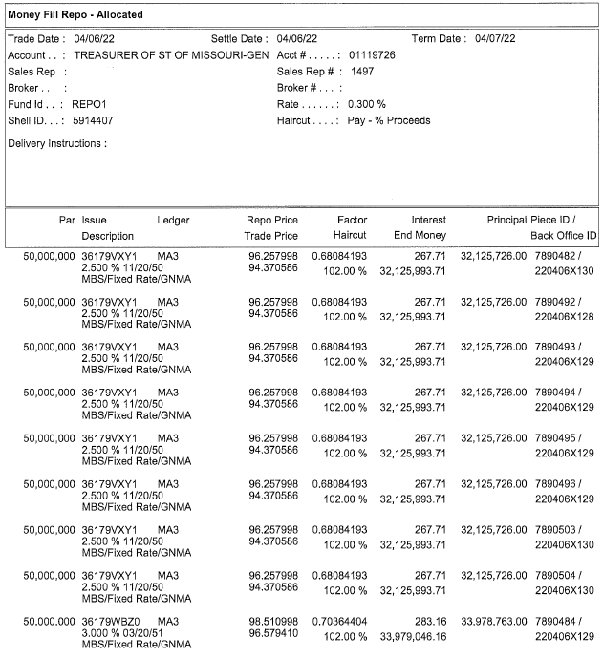
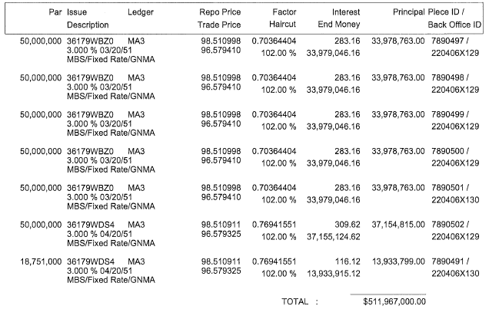

Dealer 3 Collateral

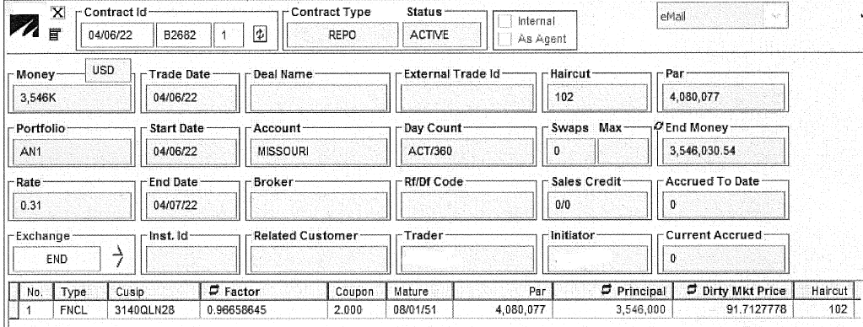

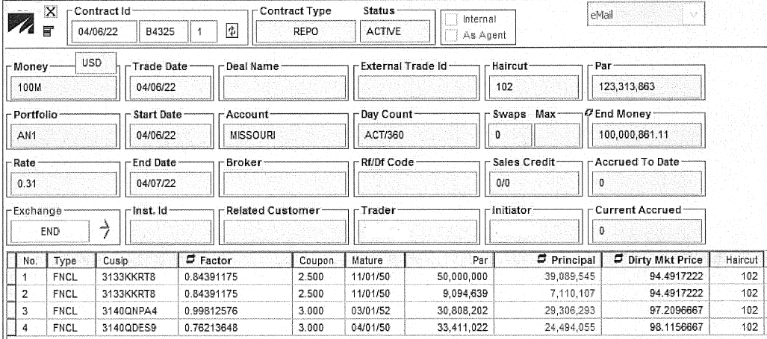

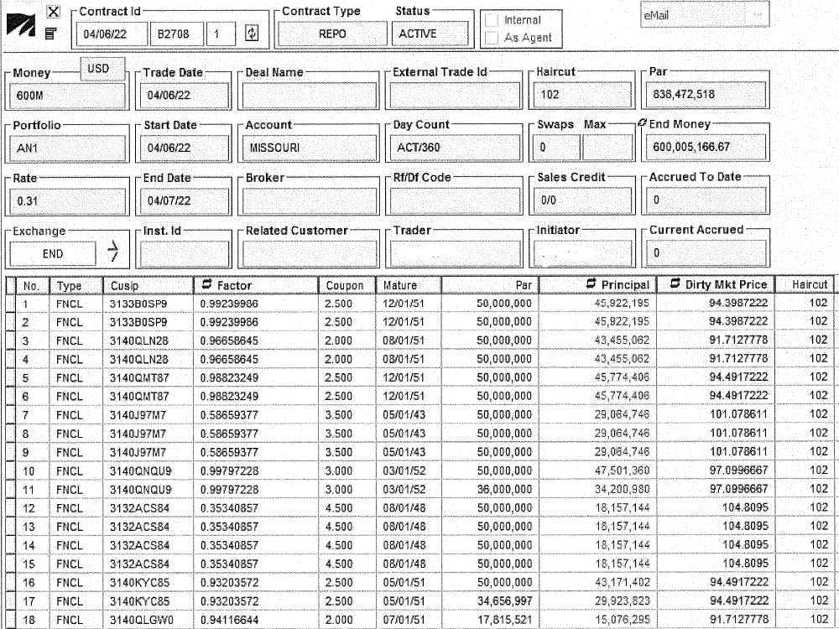

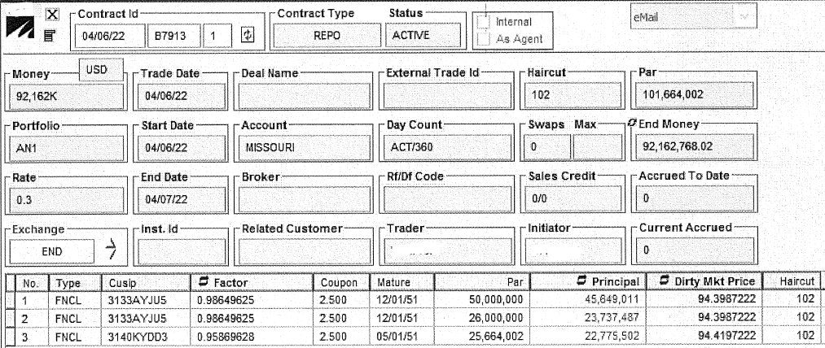

Dealer 4 Collateral
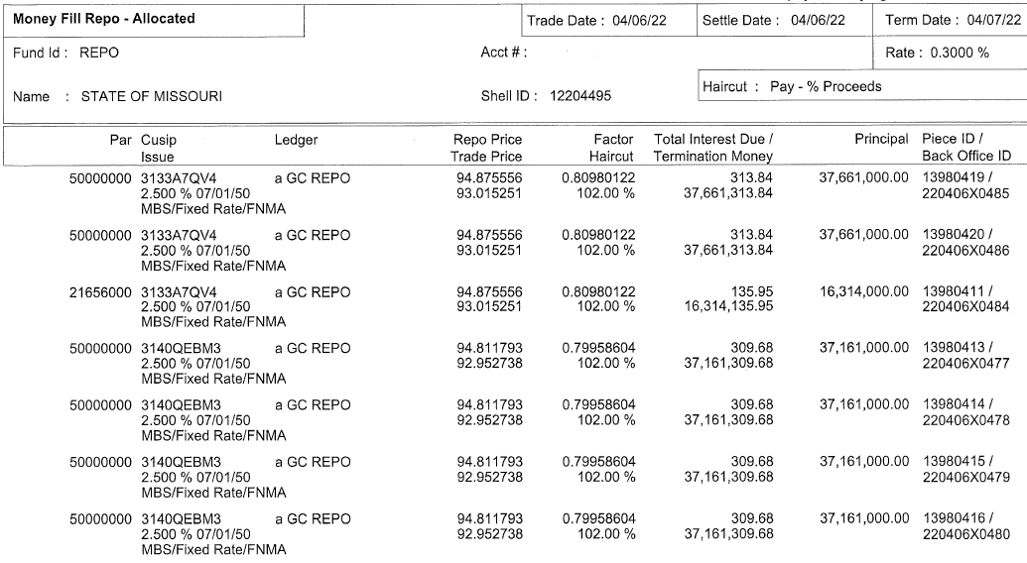
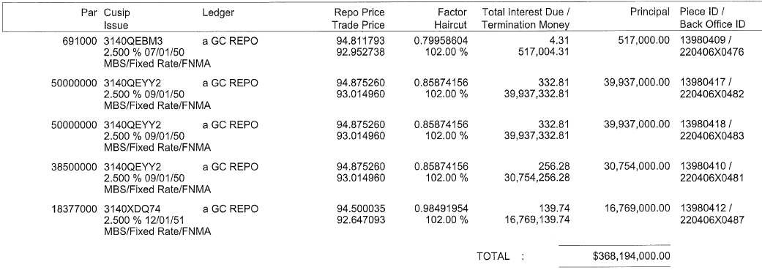

Repurchase Agreement Collateral Modification Notice (Free Piece Delivery)

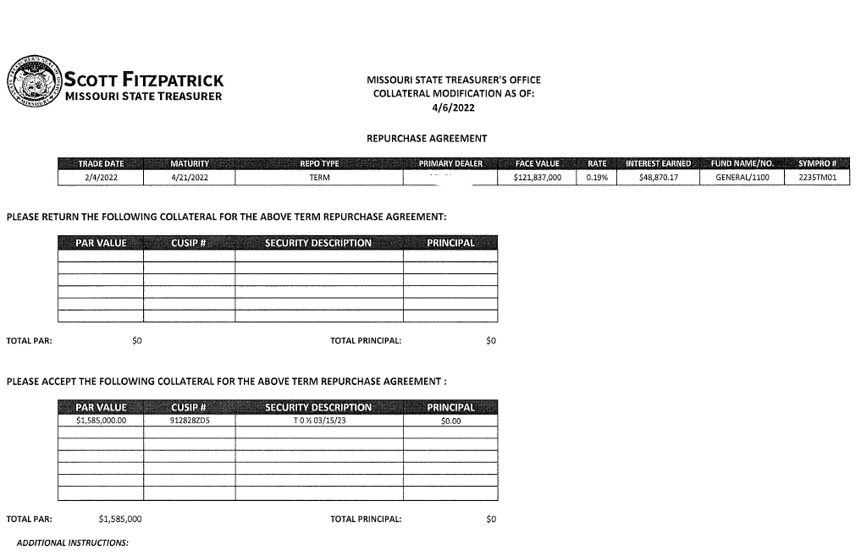

Trade Ticket for Security Purchase
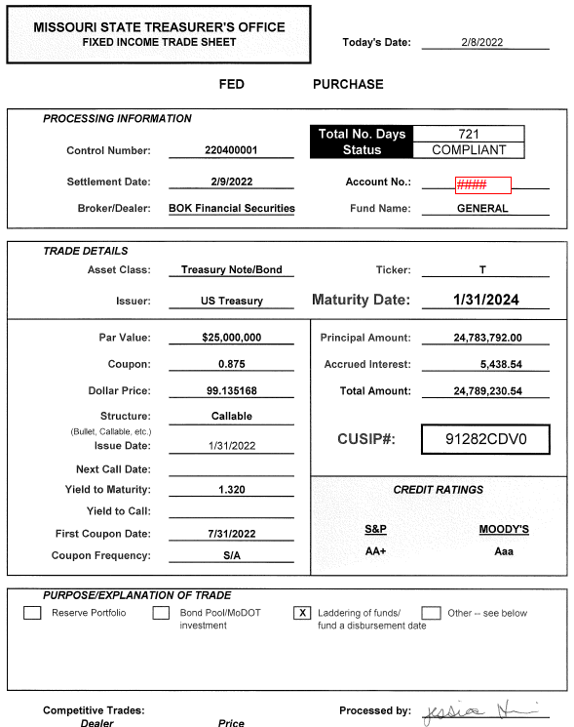

Appendix G

BUSINESS ENTITY CERTIFICATION, ENROLLMENT DOCUMENTATION,
AND AFFIDAVIT OF WORK AUTHORIZATION

BUSINESS ENTITY CERTIFICATION:
The vendor must certify their current business status by completing either Box A or Box B or Box C on this Exhibit.

BOX A: To be completed by a non-business entity as defined below.
BOX B: To be completed by a business entity who has not yet completed and submitted documentation pertaining to the federal work authorization program as described at http://www.uscis.gov/e-verify.
BOX C: To be completed by a business entity who has current work authorization documentation on file with a Missouri state agency including Division of Purchasing.

Business entity, as defined in section 285.525, RSMo, pertaining to section 285.530, RSMo, is any person or group of persons performing or engaging in any activity, enterprise, profession, or occupation for gain, benefit, advantage, or livelihood. The term “business entity” shall include but not be limited to self-employed individuals, partnerships, corporations, contractors, and subcontractors. The term “business entity” shall include any business entity that possesses a business permit, license, or tax certificate issued by the state, any business entity that is exempt by law from obtaining such a business permit, and any business entity that is operating unlawfully without such a business permit. The term “business entity” shall not include a self-employed individual with no employees or entities utilizing the services of direct sellers as defined in subdivision (17) of subsection 12 of section 288.034, RSMo.

Note: Regarding governmental entities, business entity includes Missouri schools, Missouri universities, out of state agencies, out of state schools, out of state universities, and political subdivisions. A business entity does not include Missouri state agencies and federal government entities.

BOX A – CURRENTLY NOT A BUSINESS ENTITY
I certify that _____________________ (Company/Individual Name) DOES NOT CURRENTLY MEET the definition of a business entity, as defined in section 285.525, RSMo pertaining to section 285.530, RSMo as stated above, because: (check the applicable business status that applies below)

- I am a self-employed individual with no employees; OR
- The company that I represent employs the services of direct sellers as defined in subdivision (17) of subsection 12 of section 288.034, RSMo.

I certify that I am not an alien unlawfully present in the United States and if _____________________ (Company/Individual Name) is awarded a contract for the services requested herein under ____________ (RFP Number) and if the business status changes during the life of the contract to become a business entity as defined in section 285.525, RSMo pertaining to section 285.530, RSMo then, prior to the performance of any services as a business entity, _____________________ (Company/Individual Name) agrees to complete Box B, comply with the requirements stated in Box B and provide the Division of Purchasing with all documentation required in Box B of this exhibit.

 | Authorized Representative’s Name (Please Print) |  | Authorized Representative’s Signature
 | Company Name (if applicable) |  | Date

(Complete the following if you DO NOT have the E-Verify documentation and a current Affidavit of Work Authorization already on file with the State of Missouri. If completing Box B, do not complete Box C.)

BOX B – CURRENT BUSINESS ENTITY STATUS
I certify that _____________________ (Business Entity Name) MEETS the definition of a business entity as defined in section 285.525, RSMo pertaining to section 285.530.

 | Authorized Business Entity Representative’s Name (Please Print) |  | Authorized Business Entity  Representative’s Signature
 | Business Entity Name |  | Date
 | E-Mail Address
As a business entity, the vendor must perform/provide each of the following. The vendor should check each to verify completion/submission of all of the following:

- Enroll and participate in the E-Verify federal work authorization program (Website: http://www.uscis.gov/e-verify; Phone: 888-464-4218; Email: e-verify@dhs.gov) with respect to the employees hired after enrollment in the program who are proposed to work in connection with the services required herein;
AND
- Provide documentation affirming said company’s/individual’s enrollment and participation in the E-Verify federal work authorization program. Documentation shall include EITHER the E-Verify Employment Eligibility Verification page listing the vendor’s name and company ID OR a page from the E-Verify Memorandum of Understanding (MOU) listing the vendor’s name and the MOU signature page completed and signed, at minimum, by the vendor and the Department of Homeland Security – Verification Division. If the signature page of the MOU lists the vendor’s name and company ID, then no additional pages of the MOU must be submitted;
AND
- Submit a completed, notarized Affidavit of Work Authorization provided on the next page of this Exhibit.

AFFIDAVIT OF WORK AUTHORIZATION:

The vendor who meets the section 285.525, RSMo, definition of a business entity must complete and return the following Affidavit of Work Authorization.

Comes now _____________________ (Name of Business Entity Authorized Representative) as _____________________ (Position/Title) first being duly sworn on my oath, affirm _____________________ (Business Entity Name) is enrolled and will continue to participate in the E-Verify federal work authorization program with respect to employees hired after enrollment in the program who are proposed to work in connection with the services related to contract(s) with the State of Missouri for the duration of the contract(s), if awarded in accordance with subsection 2 of section 285.530, RSMo. I also affirm that _____________________ (Business Entity Name) does not and will not knowingly employ a person who is an unauthorized alien in connection with the contracted services provided under the contract(s) for the duration of the contract(s), if awarded.

In Affirmation thereof, the facts stated above are true and correct. (The undersigned understands that false statements made in this filing are subject to the penalties provided under section 575.040, RSMo.)

Authorized Representative’s Signature |  | Printed Name
Title |  | Date
E-Mail Address |  | E-Verify Company ID Number

Subscribed and sworn to before me this _____________ of ___________________. I am
^{(DAY)} ^{(MONTH, YEAR)}
commissioned as a notary public within the County of ________________, State of
^{(NAME OF COUNTY)}
_______________________, and my commission expires on _________________.
^{(NAME OF STATE)} ^{(DATE)}

Signature of Notary |  | Date

(Complete the following if you have the E-Verify documentation and a current Affidavit of Work Authorization already on file with the State of Missouri. If completing Box C, do not complete Box B.)

BOX C – AFFIDAVIT ON FILE - CURRENT BUSINESS ENTITY STATUS
I certify that _____________________ (Business Entity Name) MEETS the definition of a business entity as defined in section 285.525, RSMo pertaining to section 285.530, RSMo and have enrolled and currently participates in the E-Verify federal work authorization program with respect to the employees hired after enrollment in the program who are proposed to work in connection with the services related to contract(s) with the State of Missouri. We have previously provided documentation to a Missouri state agency that affirms enrollment and participation in the E-Verify federal work authorization program. The documentation that was previously provided included the following.

- The E-Verify Employment Eligibility Verification page OR a page from the E-Verify Memorandum of Understanding (MOU) listing the vendor’s name and the MOU signature page completed and signed by the vendor and the Department of Homeland Security – Verification Division
- A current, notarized Affidavit of Work Authorization (must be completed, signed, and notarized within the past twelve months).

Name of Missouri State Agency to Which Previous E-Verify Documentation Submitted:
__________________________________

Date of Previous E-Verify Documentation Submission: _____________________

Previous Bid/Contract Number for Which Previous E-Verify Documentation Submitted: ________ (if known)

 | Authorized Business Entity Representative’s Name (Please Print) |  | Authorized Business Entity  Representative’s Signature
 | Business Entity Name |  | Date
 | E-Mail Address |  | E-Verify MOU Company ID Number
FOR STATE OF MISSOURI USE ONLY
Documentation Verification Completed By:
 | Buyer |  | Date

Appendix H

Community Investment Questionnaire

Appendix H

COMMUNITY INVESTMENT QUESTIONNAIRE

- Briefly describe your institution’s primary market emphasis and strategy for the next five years (e.g., retail banking, wholesale banking, full service, small business, middle market, Fortune 500, etc.) both overall and specific to Missouri.

- Identify your institution’s primary market area in Missouri. What percentage of your institution’s current loan portfolio is in this area?

- Please provide the following information for Missouri:

Total Assets $

Loans in Missouri $

Deposits in Missouri $

Non-Missouri Loans $

Non-Missouri Deposits $

- Describe your institution’s financial participation (e.g., lending, equity) in local community economic development efforts in Missouri.

- Describe your institution’s participation in small business and agricultural lending programs in your primary market area in Missouri. Provide statistics on the number and dollar amount of loans provided under these programs in Missouri.

- Describe your institution’s efforts to attract deposits or banking relationships with non-banked and under-banked customers in Missouri.

- Describe any financial literacy programs your institution offers in Missouri. Who is your target audience?

- Describe your institution’s check cashing policy for checks issued by the State of Missouri for non-customers.

- How many full-time individuals does your institution employ in the State of Missouri?

Provide your institution’s current Community Reinvestment Act (CRA) rating, your Federal Financial Institutions Examination Council (FFEIC) ID, and the agency providing the review (OCC, FDIC, …). For confirmation purposes, indicate your financial institution’s five-digit FDIC Certificate Numb

